Creative Computer



Easy Home Information Management

NOTICE:

•Throughout this manual, the command prompt as it appears on the screen is shown as an “A”, indicating the letter or alphabet mode. Due to a last minute design change, the command prompt for this mode has been changed to a “L”. It will appear on your screen as shown below.

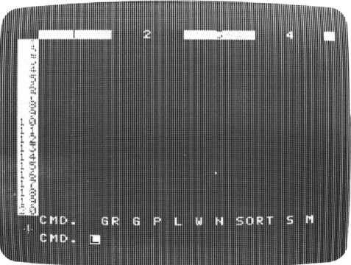

Press the FUNC and “2” keys simultaneously for caps lock.

Copyright © 1983 by SORD COMPUTER CORPORATION

All rights reserved. Printed in Japan.

No part of this publication may be reproduced, stored in a retrieval system, or transmitted, in any form or by any means, electronic, mechanical, photocopying, recording, or otherwise, without the prior written permission of SORD COMPUTER CORPORATION

**CHAPTER**

**1**

INDEX

Chapter 1 Chapter 2

Chapter 3

Chapter 4

Chapter 5

Chapter 6 Appendix

Introduction 3

What is FALC? 5

FALC Fundamentals

2-1 FALC Cassette Tape 14

2-2 Cassette Recorder 14

2-3 Inserting the FALC Cartridge 15

2-4 Keyboard 18

2-5 Using FALC as a Desk Top Calculator 21

1. 6 Incorrect Input 26

Before Using FALC 27

1. 1 Writing Characters and Numbers

on the FALC Screen 27

3-2 Changing the Cursor Direction 29

3-3 Controlling the Cursor 30

3-4 Correcting FALC Table Entries 32

3-5 Edit Mode 33

3-6 W Command Summary 34

3-7 Saving Your Completed FALC Tables

in Memory 35

3-8 Saving Your Completed FALC Tables

on Cassette Tape 36

3-9 Retrieving Saved FALC Tables

From Cassette Tape 37

3-10 What Do I Do After I Retrieve Tables

From Tape 39

1. 11 Care For Your Cassette Tapes 40

Let’s Use FALC 43

1. 1 Allowance Book Example 44

4-2 Telephone Book Example 51

1. 3 Student Exam List Example 65

More FALC Commands 83

1. 1 The Notion of a Command String 83

5-2 Programmed Functions 84

5-3 Test Score Function Example 90

**CHAPTER**

**2**

**CHAPTER**

**3**

**CHAPTER**

**4**

**CHAPTER**

**5**

Command Quick Reference

A Troubleshooting

B Care For Your FALC Cartridge

C Cassette Tape and Recorder Usage

D 32K Expansion Memory

E A Summary of FALC Commands

**CHAPTER**

**6**

Welcome to FALC, the easy-to-learn, no-programming computer language for your M5 creative computer. In endeavoring to bring computers closer to the business user, we developed a no-programming language we call “PIPS.” It enables anyone to unpack a computer and get results the very same day.

But our hope is not only to bring computers closer to non-programming businessmen, we also hope to be a part of the computer revolution enhancing the good of the common man. We have taken a subset of PIPS and offered it for your M5 computer. We call it FALC. Now, you too, can take advantage of the PIPS revolution sweeping the business computer community. It has revolutionized business programming. You will soon appreciate the power of FALC without having to understand the intricacies of software design.

FALC has been developed for the working mother, a mother at home, a working father, a father at home, or their children. Everyone can make use of it in their daily lives.

It does not require any specialized computer knowledge. By only learning ten different FALC commands and some simple rules, most household book-keeping tasks such as household accounts, address books, scheduling, daily menus, calorie count logs, etc. can be easily maintained.

Go through this manual. Play with it. Master it. Learn to utilize its potential in your family.

INTRODUCTION

This FALC manual, consisting of the following six chapters, takes you from FALC fundamentals to utilizing FALC efficiently and wisely.

What is FALC?

CHAPTER 1 CHAPTER 2 CHAPTER 3 CHAPTER 4 CHAPTER 5 CHAPTER 6 Appendix A Appendix B Appendix C Appendix D

FALC Fundamentals

Before Using FALC

Let’s Try FALC

More FALC Commands

Command Quick Reference

Clues to Troubleshooting

Care for Your FALC Cartridge

Cassette Tape and Recorder Usage

32K Expansion Memory

Chapters 1, 2 and 3 will provide a basic understanding of FALC. Take your time and read it through carefully.

Chapter 4 gives several useful examples of how to utilize FALC commands. Each example is complete as is. Pick whatever applies to your situation. Add onto it. Remember, each example does not take advantage of the full complement of FALC commands. There is still room to build or modify these learn-by-doing examples.

Chapter 5 gives some advanced FALC features. With these additions, not only will FALC be more efficient to use, it may also spark your imagination for other applications.

Chapter 6 groups FALC commands by usage. Refer to this chapter when you hit on a question. It will allow you to easily find out what to do when you need a command to perform a certain task or explain why something is done the way it is.

If you find yourself muttering “There must be something wrong with this FALC,’’ check appendix A. It gives clues to troubleshooting, while Appendices B and C give some pointers for cassette tape and recorder care. For those who want a larger FALC system, the 32K expansion memory may be just the addition for your M5 system. Read Appendix D for more information.



|  |  |  |  |  |  |  |  |  |
| --- | --- | --- | --- | --- | --- | --- | --- | --- |
|  |  |  |  |  |  |  |  |  |
| * |  |  |  |  |  |  |  |  |
|  |  |  |  |  |  |  |  |  |
|  |  |  |  |  |  |  |  |  |



Chapter 1 What is FALC?

• Basically, FALC is a blank piece of paper to write on. The only difference is it’s displayed on a TV screen. Don’t take it too seriously at first. FALC is forgiving. Play with it. Mistakes are a part of the fun while you’re learning. Like writing with a ball-point pen or a pencil on paper, you can write any character or number on the screen, anywhere on the screen. Just press the keyboard keys.



• It’s true you can write anything anywhere on the screen. But FALC’s power becomes very evident when your data is structured in tables. FALC can rearrange and compute using these characters and numbers in FALC tables. Obviously, FALC cannot do too much if this information is randomly written. So your table needs to fit a table format. It’s similar to forms you fill out at the bank or when you apply for something. Like the forms at the bank, one FALC restriction is that it can only handle a limited number of characters or numbers.



• The size of a FALC table can be changed. Before actually designing a FALC table, we should decide the size of the table which depends on the number of items to tabulate or the type of items in our table. FALC can accommodate this, just tell it the size of your table. Moreover, FALC can do many things quickly and efficiently for you that would normally take much longer. You can also alter the size of a FALC table even as you are filling in table data or after all your information has been input. You can add new rows and columns, or delete them.



• FALC allows you to easily fill in a table. For anyone who has tried, filling in a table is not easy work. In filling a table, you can easily write something wrong, skip a whole row, or duplicate some data. This is especially true when you are “pigeonholing” data after you have filled in the original table. FALC can eliminate all of these errors. You can correct or delete characters easily. FALC can rearrange and edit your table for you. All you have to do is insert table data one at a time.



• FALC can make the best of table data. The reason for arranging data in a table format is to group various information collected in your daily life so that it can be referred to easily. Already, you’ve probably designed useful tables for various purposes. You may have grouped similar data in several tables of differing formats. Of course, this can be confusing. FALC minimizes this. By defining various table conditions, you can rearrange the contents or display data to meet the given conditions. You’ll be able to make full use of your data.



• FALC is equipped with a computation function. Making beautiful tables is not all that FALC can do. Any numbers arranged in a table can be computed, either along a column or a row. The answer can then be, of course, written anywhere in the table. All you need to supply FALC is what to compute, how to compute it, and where to write the answer.

In addition, you may want to know what the answer would be if only one number is changed. Through computer technology, FALC makes this easily possible. This is called “recomputation.” Moreover, FALC can function as a handy calculator.



• FALC can make a graph instantly from table data. Up to five rows of table data can be easily graphed at the same time. Thus, numeric table data can be easily changed to visual graphics, a very useful tool for data analysis and visual comparison.



• Two different FALC tables can be stored simultaneously in the M5 computer. After completing one table, you can store it in one of the two internal memories, and recall it at will. Keep in mind though, these tables are lost once the power is turned off.

FALC tables can be stored on a cassette tape. All you need to do is assign a name to a table and copy it to a cassette tape for permanent storage. In this way, you can build a library of tables. Then when you want to retrieve this information, simply replay the tape to display a table on the FALC screen any time you want.



• You can also make a hard copy of your data. It may not be convenient to take along your M5 and TV screen when you want to show your data to others. Another FALC capability is to copy the table to a specific type of paper, commonly called a “computer printout.” However, an optional printer needs to be purchased. When connected, computer printouts of your tables are easily printed.



• What are some FALC commands? In the previous discussion, we went over what FALC can do. However, without you telling it what to do, it’ll stare right back at you without doing a thing. Interfaces from you to FALC are provided and are called commands. FALC uses only ten commands. With these ten commands, you can utilize FALC efficiently and quickly. Each of these commands is described in chapters 3 and 4 of this manual.



What’s the size of a FALC table? When the power is turned on and the FALC cartridge is inserted into the M5 console, FALC assumes the initial size shown in the following illustration. Notice it’s 60 lines with each line being 56 characters long. Each line of 56 characters is then divided into 8 columns, each containing 7 characters. The TV screen, however, doesn’t display the whole table at once. In fact, only the upper left corner is initially displayed, namely the leftmost 29 characters of the upper 20 lines. But this isn’t a problem. You’ll soon see how any part of the table is easily and quickly accessed (Chapter 3).

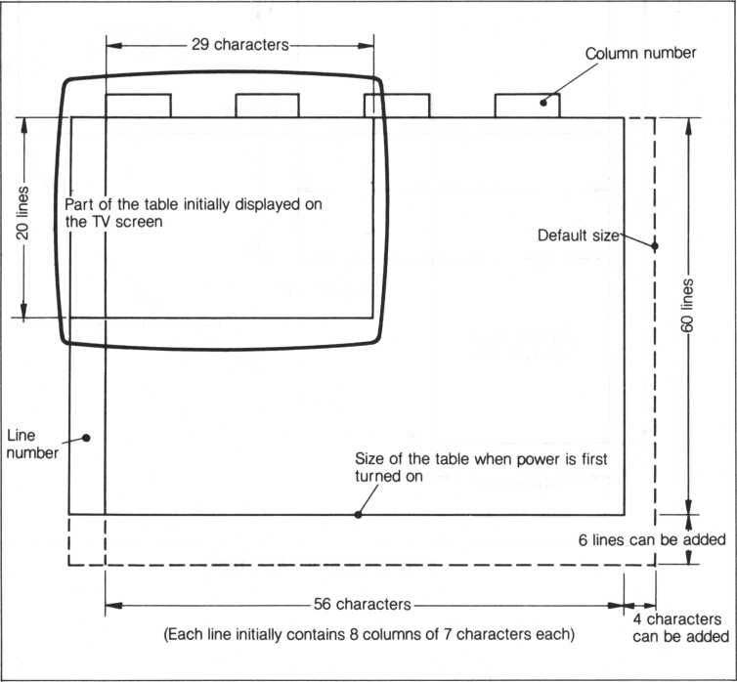

Initial size of a FALC table when power is first supplied

Although FALC sets the initial size of a table, you can change it and tailor it for your needs. There can be up to 99 lines; each tine can contain from 39 to 255 characters; each line can have up to 27 columns. Obviously, the number of characters per line must exceed the total number of characters in all columns.

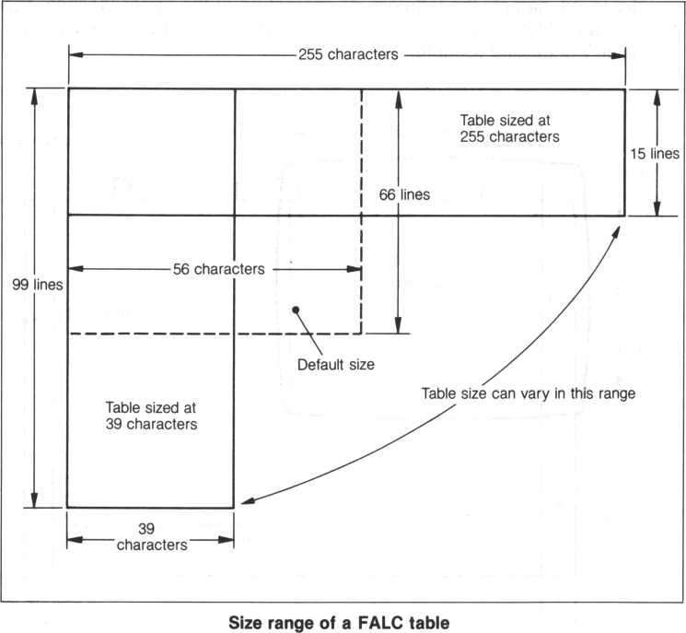

The M5 computer has two memories for ease of operation. How are the two memories and the FALC screen related? Look at the following illustration. The screen can be thought of as reflecting one of the memories where a FALC table is set up, rearranged, or has calculations performed on its data. Let’s call this work space the “monitor area.”

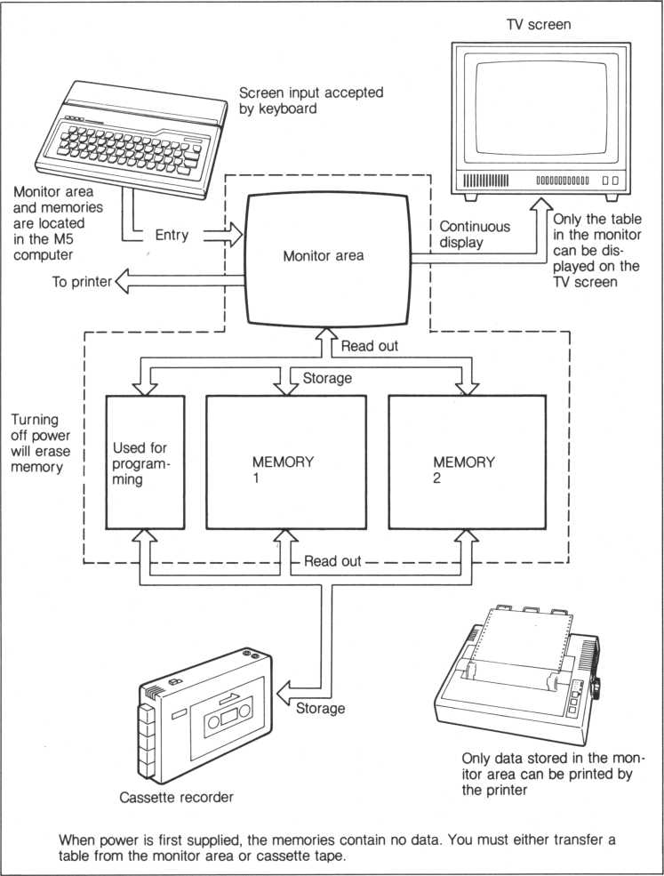

FALC monitor and memory interface



Chapter 2 FALC Fundamentals

You’ve just bought your M5 and nothing is set up? If this is the case, you’re not alone. But if you’re one of the lucky users who have already been enjoying the benefits of an M5 system, skip this section and go to section 2.1.

It’s easy, just use the easy-to-follow illustration below.

Look at the connector plugs. Each plug must be connected a particular way. Don’t force them, but they should be firmly inserted.

The system consists of the M5 console, power supply unit, cassette tape recorder, TV set, and optional printer.

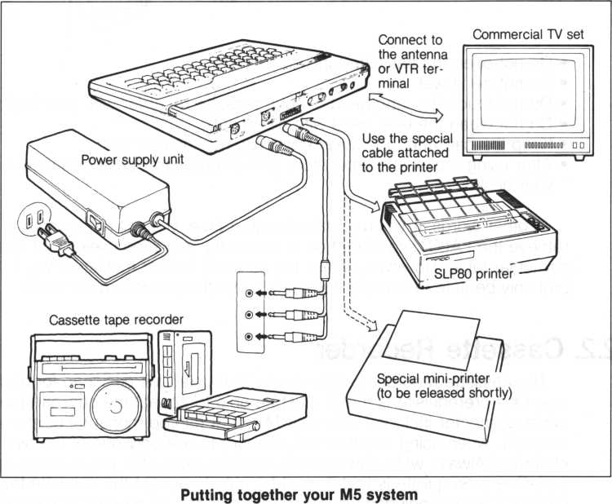

1. FALC Cassette Tape

I

Normal cassette tapes are used by FALC to store FALC information.

This data can then be retrieved again and displayed on the FALC screen, and if desired, modified and written out again to the cassette tape. Be sure to take good care of your cassette tapes. Rough or careless handling can cause problems and headaches later.

* Do not open the cassette tape cartridge



* Do not get it wet
* Do not touch the tape head of your cassette recorder with your fingers
* Do not clean the tape head with detergent
* Keep the cassette tape away from extreme heat or cold
* After using a cassette tape, store it in its protective case or safely in your desk

In other words, if you’re careless with a tape, you will not be able to retrieve the FALC data stored on it, rendering your tape useless for that particular table. However, unless the cassette tape is mutilated, you’ll probably be able to use that tape again, but the previous data is lost.

1. Cassette Recorder

The cassette recorder can be any commercial unit designed for audio use. One prerequisite is that it must be able to accept the cassette tape cable connector included with your M5 kit. It can be monaural or stereo; however, when using a stereo unit, be sure to use only one of the two channels. Always write down on the cassette tape label the channel used, use. One prerequisite is that it must be able to accept the cassette tape cable connector included with your M5 kit. It can be monaural or stereo; however, when using a stereo unit, be sure to use only one of the two channels. Always write down on the cassette tape label the channel used.



If the remote control plug of the cassette recorder connecting cable is connected to the cassette recorder (when available), FALC commands will automatically start and stop it in the record or playback modes.

The remote control plug may not fit some cassette recorders or the jack on the recorder may not be available. In this case, naturally, the two cannot be connected. This is not a problem. The automatic starting and stopping of the tape then requires manual operation.

However infrequent, FALC tables are sometimes not written perfectly to the cassette tape or they cannot be retrieved. To minimize this, pay special attention to the following.

* Use reliable high quality cassette tapes
* Use a reliable cassette recorder
* Avoid very old cassette tapes that have been used many times repeatedly.
* Keep the head and mechanism of your cassette recorder clean. Use a high quality cleaning kit to clear dirt and dust from them regularly every several hours.
* External electrical noise may mix onto your tapes, which can result in not being able to read it back. Place the recorder as far as possible from this type of electrical equipment.
* For better maintenance of your cassette recorder., carefully refer to its maintenance manual.

1. Inserting the FALC Cartridge

So now your M5 system is connected and almost ready to go. Your M5 is very flexible in what it can do. Because of this, you’ll also need to set it up for FALC operation. Use the following checklist.

1. Open the top panel of the M5 console. To do this, lift up the front of the panel with both hands as depicted below and open it. This panel can also be removed and set aside.

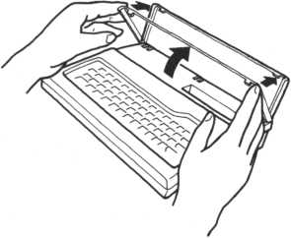

1. After checking that the power is OFF, firmly and without slanting the cartridge, insert the FALC cartridge. It is meant to be a bit hard to insert when new. But don’t force it. Notice the curved indentation on the bottom left of the cartridge. This matches the curved ridge in the M5 console slot. While the power is ON, never insert nor pull out the cartridge. Even if the power is ON, the red lamp on the console will not be lit unless a cartridge is also inserted.

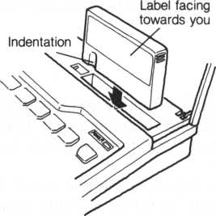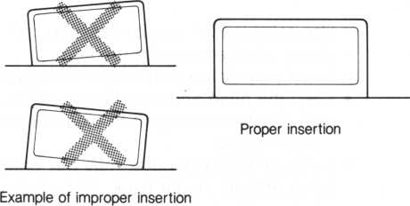

1. Turn the switch on the power supply unit ON. Before doing this, always be sure a cartridge is inserted in the M5 console slot.



1. Turn on the TV set and adjust the channel selector until the FALC screen is displayed on the TV set. When the TV set is connected at its VTR terminal, be sure to set the switch to “VTR.”

Turn the channel selector to the left or right. Fine tuning may be necessary.

Select a channel button and adjust the tuning control to the left or right

For televisions with For televisions with channel selector knobs push button tuning

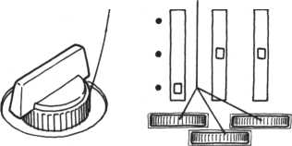

1. Turn the other parts of the system ON. The other parts, also known as peripherals, are the cassette tape recorder and printer.

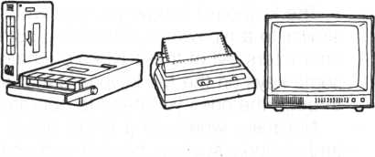

All right! FALC is now up and running! You should see the following on your TV screen. If you don’t, turn off everything and recheck all system component connections.

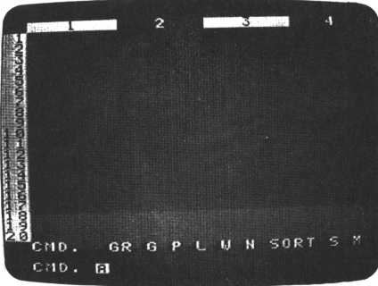

1. Keyboard

The keyboard is how you can write data onto FALC tables. Notice it’s similar to a typewriter, containing both alphabet, number and graphic characters. All of these types of characters are available. There are also some keys on the M5 keyboard that are not on a typewriter. We’ll go through the ones you need to operate FALC efficiently.

Normally, when using FALC, upper and lower case alphabets, numbers and symbols such as periods and commas, are used. To access the graphic characters, you must change the mode of the keyboard. Note that when you change the mode, you must then change the mode back to access the previous type of character. For example, all commands must be input in the alphabet mode; after switching to the graphics mode, you must switch back to the alphabet mode to input another FALC command.

Let’s go through switching of keyboard modes.

Alphabet Mode

* This mode must be used when inputting FALC commands or writing alphabets or numbers on a FALC table. This mode is similar to a typewriter, e.g., upper case alphabets are input by pressing the alphabet key and the SHIFT key at the same time.
* Just after starting FALC operation, the keyboard assumes this mode. When in this mode, the cursor blinking at the lower left of the screen is an “A”.
* When you want to enter this mode, press the FUNC key at the upper left of the keyboard and the 1 key simultaneously.

Alphabet mode characters when SHIFT key is not pressed

FUNC

- ALPHA key

Alphabet mode characters when SHIFT key is pressed simultaneously

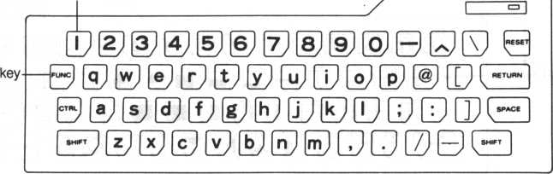

**(DD©©S®D[D[DD00[D 9 0 ® 0 ® ® E © © 0 ® ® D GD 03**

SHIFT key (either SHIFT key may be used)

Graphics Mode

* Graphic characters are as the name implies.

You can draw pictures by using one or a combination of graphic characters.

* The SHIFT key is also used in this mode, e.g. one set of graphic characters is available with the SHIFT key not pressed. Likewise, another set is available when pressed.
* When you want to enter this mode, press the FUNC key and the 3 key simultaneously.
* This mode is indicated by a “G” blinking cursor.

Graphics mode characters when SHIFT key is not pressed

► GRAPH key

FUNC key

0 0 B IP P 0J 0 B P P 0

J SHIFT J

^ SHIFT I

Graphics mode characters when SHIFT key is pressed

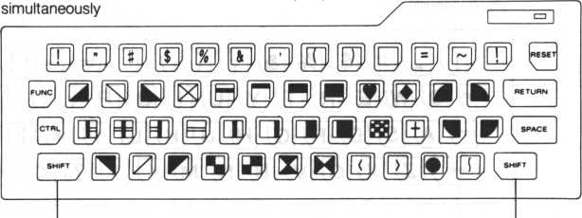

SHIFT key (either SHIFT key may be used)

1. Using FALC as a Desktop Calculator

We’re now ready to try something useful. To start off, let’s use FALC as a desktop calculator. Be patient. All we want to do here is become familiar with FALC before moving on to more sophisticated functions.

You do not need to input commands when using FALC as a calculator. Rather, when FALC is first turned on and the COMMAND prompt is displayed in the lower left corner, you can input a normal mathematical formula using the keyboard.

The following tables describe the set of available mathematical symbols. Notice some symbols, such as multiplication, are not identical to what you learned in school.

Parentheses can also be used in a formula. In fact, nested parentheses (parentheses within other parentheses), are also permitted.

**Mathematical symbols**

|  |  |
| --- | --- |
| Symbol | Calculation |
| + | Addition |
| — | Subtraction |
| * | Multiplication |
| / | Division |
| < | Exponentiation (real number) |
| * * | Exponentiation (integer) |
| Function symbols | |
| Function | Calculation |
| ABS(X) | Absolute value |
| SIN(X) | Sine |
| COS(X) | Cosine |
| TAN(X) | Tangent |
| EXP(X) | Exponential |
| LOG(X) | Logarithm |
| LN(X) | Natural logarithm |
| SQR(X) | Square root |
| SGN(X) | Sign |
| INT(X) | Integer |

’X’ enclosed in parentheses is supplied by you. Use radians for all trigonometric operations.

If you input a mathematical formula to the right of the COMMAND prompt and enter an “ = ” at the end of the entry, FALC will not display the answer. Instead of entering an “ = ”, FALC requires you press the RETURN key at the right side of the keyboard. FALC will then instantly display the answer to the right of the formula. If the formula is too long to fit on one line, the answer may be displayed on the next line. The maximum number of characters per formula is fifty numbers and symbol characters.

If you then want to make another calculation, press the RETURN key again and the COMMAND prompt will reappear for your next input.

■ CTRL key—controls keyboard functions

RETURN key—pressed at the end of an M5 command

FUNC key—used to access ' character modes and key functions

RESET key—used together with the SHIFT key to return to the COMMAND- prompt mode

SHIFT key—used to double the number of available characters

SHIFT key—identical to the SHIFT key to the left

SPACE key—makes a space on the screen

Let’s try some calculations.

|  |  |  |
| --- | --- | --- |
| Formula | Key Operation | |
| 5 + 7 | 5+7 RETURN | |
| COMMAND | QR G F | > L. W N SORT S M |
| COMMAND | 5+7 12 |  |
| 12-9 | 12-9 | RETURN |
| COMMAND | GR G P L W N SORT S M | |
| COMMAND | 12-9 3 | | 0 |
| 3x9 | 3 * 9 RETURN | |
| COMMAND | GR G F | ■ L V N SORT S M |
| COMMAND | 3*9 27 | A |
| 15-5-9 | 15/9 RETURN | |
| COMMAND | GR G F | ■ L U N SORT S M |
| COMMAND | 15/9 1. | 666666666666666 [a] |
| (3 + 4) X (9-3) | ( 3 + 4 ) | * ( 9 - 3 ) RETURN |
| COMMAND | GR G P L W N SORT S M | |
| COMMAND | (3+4) + (9-3) 42 (A] | |

|  |  |
| --- | --- |
| Formula | Key Operation |
| 52 | 5 - 2 RETURN |
| 52 | 5**2 RETURN |
| COMMAND | 5"""2 25. 002 0 |
| COMMAND | 5**2 25 0 |

Use of ** for exponentiation will result in better precision

|  |  |  |  |
| --- | --- | --- | --- |
| Formula | Key Operation | | |
| sin (1.57) | S I N ( 1 . 5 7 ) RETURN | | |
| COMMAND | GR G P L U | N | SORT S M |
| COMMAND | sin (1.57) 1 | A |  |
| COS (0) | C 0 S ( 0 ) RETURN | | |
| COMMAND | GR G P L W | N | SORT S M |
| COMMAND | cos (0) 1 [A] |  |  |
| tan (0.5235) | T A N ( 0 . 5 2 | 3 5 ) RETURN | |
| COMMAND | GR G P L W | N | SORT S M |
| COMMAND | tan(0.5235) | 0. | 577219 [A] |

Use radians for all trigonometric operations

|  |  |
| --- | --- |
| Formula | Key Operation |
| log (10000) | L O G ( 1 0 0 0 ) RETURN |
| COMMAND | GR Q P L W N SORT S M |
| COMMAND | l o g < 10 0 0) 3 [A] |
| , i-j r^rw natural log (7.39) logarithm | L N ( 7 . 3 9 ) RETURN |
| COMMAND | GR G P L W N SORT S M |
| COMMAND | In (7. 39) 2.00013 ® |
| sqr (15) | S Q R ( 1 5 ) RETURN |
| COMMAND | GR G P L O N SORT S M |
| COMMAND | sqr(15) 3.87298® |
| sqr log(1000) xlog(100000) | S Q R ( L O G ( 1 000)* LOG ( 1 0 0 0 0 0 )) RETURN |
| COMMAND | GR G P 1. O N SORT S M |
| COMMAND )) 3.872 | sqrdogd 0 0 0 > *1 © g (10 0 000 :9B ® |
| sin (cos(2)x52+log(3) | SIN(COS(2)*5**2 + LO G ( 3 ) ) RETURN |
| COMMAND | GR GPL W N SORT S M |
| COMMAND s i n(cos C 2)*5**2 +lo g(3>) 0.480984 ® | |

1. Incorrect Input

If you find incorrect characters or numbers in your commands or formulae, or even while writing on a FALC table, you can correct them. There are actually several methods to accomplish this. But first, look at the following keyboard. Note the location of the CTRL, DEL, X and RESET keys.

Key combination to delete one character i RESET key

|  |  |
| --- | --- |
| / \| POWER | | A  CJ | |
| SSSOSOOBBEDDD ( | 3— |
| 0 ® ® ® ® ® G? 0 B 0 ID (” | RN |
| -r=000®0©0000iD0[Db | *CE |
| V | J |

Key combination to Key combination to

delete one line return to the COMMAND

prompt mode

The first method is to delete characters one at a time while the cursor is moving backwards. It’s done by pressing the CTRL and DEL keys simultaneously. The cursor will backstep one character. Consequently, the previous character is deleted. You can now input the correct character. Keep pressing this combination of keys as many times as necessary until the cursor rests at the incorrect letter.

Another method is to delete the whole input line and start over. Just press the CTRL and X keys at the same time to delete the entire previous entry. The cursor also moves back to its leftmost position in the entry field. Now you can start over.

If you press the RETURN key after detecting a faulty entry and the COMMAND prompt reappears, the system has ignored your input and has reset itself. You can then start over.

However, if you incorrectly input an entry and the screen changes color or the COMMAND prompt does not reappear, manually reset the system by pressing the SHIFT and RESET keys simultaneously. The COMMAND prompt will appear and you’re off and running again.

Chapter 3 Before Using FALC

1. Writing Characters and Numbers on the FALC Screen

The W command is used to write characters, numbers and miscellaneous symbols on FALC tables (on the screen). Once you enter the W command mode, there are two ways to do this. One method is to write them in order by line and column. The other way is to write them free format. The difference between the two methods may not be clear to the uninitiated. The first, writing by line and column, is controlled by FALC and aids in inputting a large quantity of data. All you need to do is input data one at a time without regard to the format. FALC takes care of the rest. The latter, free format, allows you to completely control everything. You can choose explicitly where data should reside. In other words, free format allows you to "freely” format data.

If the W and RETURN keys are pressed when the COMMAND prompt is displayed at the bottom left of the FALC screen, the screen will change to the following illustration. The screen will be green (if a color TV set is used).

Cursor denoting field to fill (input by line and column mode)

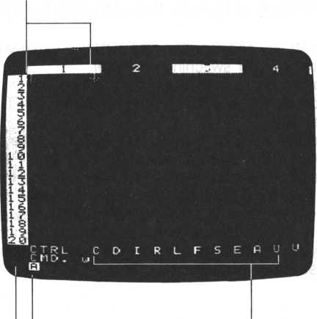

—Describes keyboard mode Commands available

under the W command

Arrow showing direction cursor will move when one field is filled

A reminder. You may need to enter a different keyboard mode depending on the type of character you want to input. Refer to the section 6n using the keyboard in the previous chapter (page 18).

Let’s try to write some characters on the screen. Press any of the character keys. Press some alphabet character keys and some numbers. Change the keyboard mode and type in some graphics characters. Then change the keyboard mode back to alphabetic and type in some more alphabets and numbers. Look at the FALC screen. See what happens? When you press keys, you will see the same characters reflected on the screen just outside of the cursor, [ ]. The cursor continues to get smaller by one character each time a new character is input. The maximum number of input characters is limited by the number of characters that can be contained in the cursor.

After inputting up to the maximum number of characters allowed per field, press the RETURN key. In fact, always press the RETURN key after inputting a set of characters or symbols within the cursor. This informs FALC that inputting of one field is finished. So, unless you press the RETURN key, FALC will not be able to separate your input correctly. Your input is liable to look like random input. (This is similar to pressing the W key followed by the RETURN key. It informs FALC a W command has been input. Without pressing the RETURN key, nothing changes on the screen.) Let’s go through an exercise to confirm how the RETURN key works.



1. Press the W key and then the RETURN key when you see the COMMAND prompt after switching on power.
2. Type in a few characters (fewer than seven).
3. Without pressing the RETURN key, press the SHIFT and RESET keys simultaneously.
4. Again press the W key followed by the RETURN key. Notice what happened to your characters? They’re now gone.
5. Now type in more than seven characters. Notice the cursor moves to the next field. Yes. Inputting more characters than one field can accommodate is identical to pressing the RETURN key after seven characters. But this is somewhat dangerous. This input procedure only works if your data always contains the number of characters in a column, seven in this case.
6. Now type in a few characters followed by a RETURN key. Do this a few

times.

1. Press the SHIFT key and RESET key at the same time to go back to the

COMMAND prompt screen.

1. Once again press the W and then the RETURN key.

How was your exercise? There were characters left on the screen after step 3, but they disappeared when you input the W command again in step 4 since a RETURN key was missing. But input from steps 5 onward will be retained since a RETURN key was input or was implied. The cursor moves to the next field after filling in one field.

After inputting all characters, the SHIFT and RESET keys are pressed simultaneously to change the screen back to the COMMAND prompt mode.

1. Changing the Cursor Direction

After filling one field, the cursor automatically moves to the next field. Notice the next field can either be the field to the right or the field below the current field. FALC allows you to set this parameter, e.g. change the cursor direction.

When FALC is first activated (after power up), the direction of the cursor is assumed to move to the next field below. When that particular column is filled, the cursor moves to the top of the next column.

You can change the cursor so that it moves to the next field to the right of the current field. To do this, press the CTRL key on the left side of the keyboard and the C key simultaneously. Pressing it one more time changes it back as before (to move downward).

Look at the arrow situated at the bottom left of the screen. This indicates the cursor direction. When the arrow points down, the cursor moves downward after filling a field. When the arrow points to the right, the cursor moves to the right after filling a field. Remember, each time the CTRL key and the C key are pressed simultaneously, the arrow direction changes.

When the cursor When the cursor

moves downward moves to the right

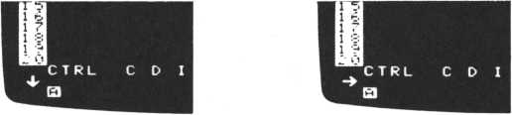

The usage of CTRL C in this context is available only in the W command mode.

1. **Controlling the Cursor**

For most applications, it is very convenient to be able to freely move the cursor. Of course, this feature is also supplied with FALC. This is done with cursor control keys. Look at the right side of the keyboard. In the left corner of four keys, you’ll see —, 1, —, t, and printed on the left upper portion of the keys. These are cursor control keys.

To use these keys, you need to press the CTRL key and then one of these keys simultaneously. This forces the cursor to move in that direction. Try them out.

CTRL and — : cursor moves to the left CTRL and — : cursor moves to the right CTRL and t : cursor moves up CTRL and 1 : cursor moves down

Usage of the cursor control keys is available only under the W command. It is not available in the COMMAND prompt mode.

You can also move the cursor immediately to anywhere on the displayed screen. This means you don’t need to move the cursor one field at a time until the correct field is found. To do this, simply type in a W followed by the line number, column number and RETURN key. For example, type in W 1 , 3 RETURN. See what happened? The cursor went straight to column 3 of line 1. This field is now also at the leftmost top corner of the displayed screen. It’s especially handy when you need to move the cursor a long distance.

The general case is described below:

W Line no. , column no. RETURN

Just after switching power on, a FALC table consists of eight columns of seven characters each and sixty six lines. Two examples using the W command just mentioned follow.

i 1 Cursor

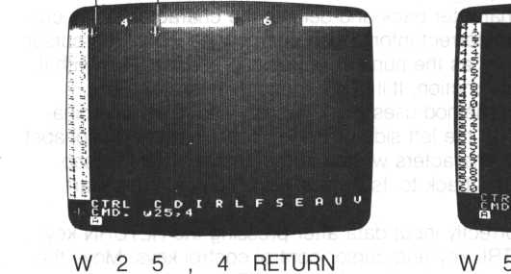

■

>0,7 RETURN

Let’s go through another example. Moving the cursor to the leftmost corner (column 1 of line 1) of our FALC table can be done two ways.

One method is to use the CTRL key and cursor control keys to move the cursor until it rests at the leftmost corner.

Another method is to press the SHIFT and RESET keys together to bring the FALC screen back to the COMMAND prompt, and then to type in W 1 , 1 RETURN.

1. **Correcting FALC Table Entries**

Fixing incorrect input during the COMMAND prompt mode has already been discussed. Likewise, correcting bad input while writing to a FALC table can be done in a like fashion.

If you detect erroneous input before pressing the RETURN key, one of two correction methods can be employed. The first uses the CTRL key and DEL key combination. Press the CTRL key at the left side of the keyboard and the DEL key at the top right of the keyboard simultaneously. This moves the cursor one character back and deletes the character at the cursor’s former position. The correct information can now be input. The cursor moves back as many times as the number of key depressions. Play with it. Become familiar with this function. It’ll come in handy later.

The second correction method uses the CTRL key and X key combination. Press the CTRL key at the left side of the keyboard and the X alphabet key at the same time. All characters written at the cursor position disappear and the cursor reverts back to its original size. You can then start over.

If you find you’ve incorrectly input data after pressing the RETURN key, you’ll need to use the CTRL key and cursor control control keys. Move the cursor back to the incorrect position by using the CTRL key and arrow keys. Correct the character(s) and press the RETURN key. The old data already displayed disappears and the new input characters are substibuted in their place. Remember, unless you press the RETURN key, previously input incorrect characters will not be substituted even though the cursor has already moved to the next field; just pressing the RETURN key doesn’t make any sense.

If you find you’ve made a mistake while trying to correct erroneous data, the CTRL and DEL keys are useful. Simply press the CTRL and DEL keys together to backspace until the erroneous data is deleted. Now input the correct data, followed by the RETURN key. This can be done as often as necessary.

1. **Edit Mode**

The edit mode allows you to choose the position of input data. FALC does no formatting for you. You’ll probably occasionally find this mode convenient. You can use this feature only while in the W command mode. Follow the procedure below to find out how it works.

1. Press the CTRL key and E alphabet key together once. At this point, you don’t need to care about the cursor position. The cursor, [ ], in the table disappears and an “A” cursor blinks at the top left of the table.
2. Move the cursor to the desired position by using the CTRL key and the four cursor control keys. You can move the cursor one character to the right, to the left, up or down by pressing the CTRL key and one of the arrow keys simultaneously. Continued pressure on one key will move the cursor continuously.
3. Input desired characters and symbols. When you want to input graphic characters, you need to change the keyboard mode.

One character can be input repeatedly.

When more characters are input than one line of the displayed screen can accommodate, the cursor starts over at the beginning of the line.

1. Use steps 2 and 3 to enter characters and other symbols freely.
2. After finishing input of data, press the CTRL key and the E key once again to bring the screen back to the normal W screen mode. If you don’t change the screen back by pressing the CTRL and E keys after inputting, the newly written characters are not retained.
3. **W Command Summary**

When entering the W command mode from the COMMAND prompt mode, several functions are available. They are summarized below. Note if the CTRL key or SHIFT key is listed together with another key, the CTRL key or SHIFT key should be pressed first, and then the other key should be pressed.

Command format: (1) W RETURN

(2) W line number, column number RETURN

|  |  |
| --- | --- |
| Operation | Function |
| CTRL and cursor control keys | Move the cursor |
| CTRL and C keys | Change the cursor direction |
| CTRL and DEL keys | Correct erroneous characters |
| CTRL and X keys | Delete input line |
| SPACE and RETURN keys | Delete field entry |
| SHIFT and RESET keys | Return to COMMAND prompt |
| When the edit mode is entered in the W command mode, several more key operations and functions are possible. They are summarized below. | |
| Operation | Function |
| CTRL and cursor control keys | Move the cursor. |
| CTRL and DEL | Correct erroneous characters (Use it with care.) |
| CTRL and X keys | Delete one complete line. The cursor moves to the beginning of the line. |
| CTRL and J keys | Delete one complete line. The cursor stays at the same position. |
| CTRL and K keys | Move the cursor to the beginning of the same line. |
| CTRL and N keys | Same as CTRL and K keys above. |
| CTRL and P keys | Insert Mode—Allow you to insert characters in text. |
| CTRL and 0 keys | Release insert mode |
| CTRL and E keys | Release edit mode |

There are several more functions that will be introduced in Chapter 4. They are the CTRL and S keys, CTRL and I keys, CTRL and D keys, CTRL and P keys, CTRL and L keys, CTRL and F keys, and the CTRL and A key combination.

1. **Saving Your Completed FALC Tables in Memory**

The FALC table containing characters and numbers is only displayed on the FALC screen (monitor). It has not yet been saved. If you turn the power unit switch off, all of the above is lost. So you need to save it on a cassette tape. FALC supplies you with two pages of memory and the monitor area to make saving FALC data on cassette tapes easy and convenient.

The relationships of the FALC screen, monitor, the two memories, and cassette tapes are described in the latter part of Chapter 1 in this manual.

Before saving a FALC table on tape, the first thing we need to do is to save the completed table in one of the memories. Remember, while you’re working on your FALC table, it resides in the monitor area and not one of the two memories. The monitor is not meant to be a permanent area to store your table, just a work area.

We’ll go through an exercise to illustrate these relationships.

1. Change the screen to the COMMAND prompt mode by pressing the SHIFT and RESET keys simultaneously.
2. Let’s save our table in one of the two memories. Press the P key followed by the RETURN key. (A memory aid—“P” signifies “putting” a file somewhere.)
3. A “NAME ?” prompt now appears. In this case, let’s store our table in memory number 1, otherwise called “.1”.

Type in . 1 RETURN. Our table is then copied to memory number 1.

1. Now change the table on the screen in any way.
2. Change the screen to the COMMAND prompt mode.
3. Let’s retrieve the table we just stored. Press the G key followed by the RETURN key. (A memory aid—“G” signifies “getting” a file.)
4. Again, a “NAME ?” prompt appears. Since we stored our table in memory number 1, type in . 1 RETURN.
5. Your old table reappears on the screen. Recognize it?

Let’s discuss what we just did. First, we created or modified a FALC table in the monitor area. At this point, there is nothing in either of the two memories. Then, in steps 2 and 3, we copied our table in the monitor area to memory number 1. Memory number 2 is still vacant.

Now we have two identical copies of the same table; one copy is stored in the monitor area, the other is in memory number 1. Then in step 4, we changed the copy in the monitor area. Remember, the monitor area is working storage and not meant for keeping complete tables.

Steps 6 and 7 saw us retrieving a copy of the old version in memory number 1 and storing it in the monitor area. Notice this action destroyed the version we modified in the monitor area. Again, we have two copies of the old table, one in the monitor area and the other in memory number 1.

Likewise, memory number 2 can be accessed in the same way. Instead of typing a period followed by the number 1, type in a period and the number 2.

Flipping back and forth between the two tables is easy by using a series of G commands. Upon retrieving a table, if the table requires modification, modify it and store it in one of the memories with the P command. Try several tables.

1. **Saving Your Completed FALC Tables on Cassette Tape**

After turning the power switch off, any information in the monitor and two memories is lost. To retain this information, we need to save it on cassette tape.

We’re going to use a variation of the P command we just learned. In this case, instead of inputting a memory number, we’re going to assign a name to our FALC table. The period is omitted. In fact, FALC uses the period to determine if you want to save/retrieve tables in/from memory or on/from cassette tape.

If it sounds a bit confusing, relax. We’ll go through an exercise that’ll teach you enough to be an expert.

First, be sure your system is connected properly. Check the connections between your M5 console and the cassette recorder.

1. Create a table and store it in memory number 1
2. Create another table and store it in memory number 2
3. Change back to the COMMAND prompt mode
4. Insert the cassette tape into the cassette recorder and set up the recorder to record; start recording.

If you have an auto level cassette recorder, you don’t need to adjust the recording level. But if you are using a manual type, adjust it according to its instruction manual.

Refer to Chapter 3 and your cassette tape recorder manual if you need help.

1. Press the P key followed by a RETURN key
2. When the “NAME ?” prompt appears, we need to pick a name for our tables. This example uses “TEST”, but you can use anything you desire. We’ll type in T E S T followed by the RETURN key.
3. Your FALC tables are now being written to cassette tape. When finished, FALC will give you a new COMMAND prompt.

Any time the P command is used in this fashion, tables in both memory numbers 1 and 2 are saved simultaneously. The table in the monitor area is not saved. A thirty minute tape (15 minutes on each side) can store about sixty tables.

Although any name can be chosen for the tables, it’s a good idea to pick names that represent the information on the table. Both alphabets and numbers can be used, but don’t embed spaces in the name.

It’s also a good idea to write something descriptive on the label of the cassette tape case. Write the name of the tables and perhaps some notes to yourself about the tables.

1. **Retrieving Saved FALC Tables from Cassette Tape**

Well next go on to learning how to retrieve the tables we just saved. After retrieval, we can display them on the FALC screen. We can then modify them and save them again on cassette tape.

Let’s go through another exercise.

1. Insert the cassette tape containing the tables you want to retrieve in the cassette recorder
2. Adjust the playback volume to just below the maximum; about 7~8 should be sufficient.
3. Change back to the COMMAND prompt mode
4. Press the G key followed by the RETURN key.
5. When the ‘‘NAME ?” prompt appears, we need to type in the name< of table we want to retrieve. In this example, we used “TEST”, so type in TEST followed by the RETURN key.
6. Start playing back your cassette recorder. Refer to your instruction manual if you need help.
7. When your FALC tables have been retrieved and stored in memory numbers 1 and 2, FALC will give you a new COMMAND prompt.
8. You can now display your tables with the G command (specify the memory number), or modify them.

If the two memories contain any tables prior to a G command retrieval from tape, they are erased and the ones retrieved from cassette tape are saved.

The name you input for the “NAME ?” prompt must be exactly identical to the name of the tables you want to retrieve. Missing just one alphabet or number will not suffice.

If you did not retrieve the correct data although your sequence corresponded to this explanation, turn the sound volume up a little and try the same operation once again.

When you have many tables stored on a tape, it is a bit tiresome to retrieve tables stored in the middle or end of the tape. In this case, it is possible to retrieve a table in a relatively short time by predicting where it is recorded. There are several ways to do this.

One method is to write down the tape counter value when a table is written to tape. If this is done, perform the following. Remember to reset the tape counter when writing a table out to cassette tape.

Method 1—Memorize the tape counter

1. Insert the correct tape in the cassette recorder
2. Disconnect the remote control cord and reset the tape counter to zero after rewinding the tape
3. Forward the tape while watching the tape counter. Stop it a bit before the number of the memorized counter.
4. Reconnect the remote control cord
5. Perform the operation to retrieve a FALC table above

The other method is used when only the sequence of the tables are known.

Method 2—When the table names are known

1. Insert the correct tape in the cassette recorder
2. Disconnect the remote control cord and earphone and listen to the cassette recorder
3. After rewinding the tape, fast forward the tape to count the number of stored tables. There is always a small interval of silence between one set of recorded tables and another. There is also a high pitched tone at the beginning of each recorded section. Listen for the silent intervals and high pitched sounds.
4. Stop the tape. Then look for the beginning of a silent recorded interval.
5. Reconnect the remote control cord and earphone and adjust the sound volume back to the original volume.
6. Use the previously discussed procedure to retrieve the table.

If there is no remote control connection, it is not necessary to connect or disconnect it.

1. **What to Do After Retrieving Tables From Tape**

If you retrieve a FALC table from cassette tape, it will not be displayed immediately. Because it is first saved directly in one of the memories, you need to recall it from memory with a G command. Remember the G command retrieves a table from a memory and stores it in the monitor area and displays it on the FALC screen. If you’ve forgotten how to use the G command, refer to section 3.7.

You can retrieve and use the same table many times. You can then save the altered screen or you can turn the power off. Don’t forget though, memory is cleared when you turn off power.

1. **Care For Your Cassette Tapes**

If you’re careless with your cassette tapes, FALC tables stored on tape may be inadvertantly erased. Another condition caused by tape neglect may be an inability to read the tape. Keep your cassette tapes away from excessive heat, moisture and cold. Another thing you should not do is place your tapes near magnetic fields. Magnetic fields alter your FALC tape data. Once altered, you’ll not be able to retrieve it or bad data will be retrieved. An example of a magnetic source is a stereo speaker. Babying your tapes will aid your tapes in providing good service for a long time.

Before you insert the cassette into your tape recorder, be sure the tape is completely wound onto the take up spool. If you see some slack tape in the cassette window, wind it up using a pencil as shown in the following illustration and insert the cassette. Not doing this may result in the tape getting stuck or “eaten” by your tape recorder. Obviously, this will result in a loss of FALC data.



If you want to permanently save the FALC data on a particular cassette tape, break off the tabs on the top side of the cassette. There are two tabs, one tab per side. As you look at a tape, the side facing you corresponds to the tab on the left. Turn the cassette over, and the same thing is true for the opposite side. Break off the tab(s) for the side(s) you want to permanently save. Once broken off, you will not be able to push the RECORD button on your tape recorder.

Cover exposed indentation with cellophane tape

To save data on side facing up, break off tab as shown

To re-record data on cassette tape

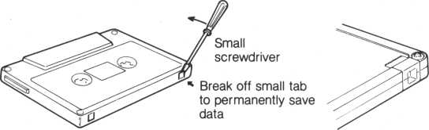

I

It’s also a good idea to put labels on each of your tapes. Write down FALC table names and possibly a short note to yourself. For example, write down the tape counter value for each table. This information may help to prevent accidental erasures of FALC data. Also, after adding new FALC data to a tape, read it back and verify that it actually has been written and can be accessed. If it has not, the connections to/from your tape recorder may be wrong or the volume level may be set too low.

You should develop a habit of frequently copying your important tapes to separate back-up tapes. This is especially important for your FALC tables that are frequently used.

\

|  |  |  |  |
| --- | --- | --- | --- |
|  |  |  |  |
|  |  |  |  |
|  |  |  |  |
|  |  |  |  |

/

**Chapter 4 Let’s Use FALC**

A basic explanation of FALC is included in Chapter 3. Here, we’ll explain FALC commands with example tables. We’ll create them and then modify them. Since these are only examples, feel free to modify them as you like. Arrange them according to your own applications and get a feel for what FALC can do for you.

Since this chapter contains examples designed to help you understand FALC, it can be read at your leisure anytime you like. After understanding Chapter 3, it’s a good idea to venture into this chapter and play with these examples. Then try some real-life problems. You’ll soon realize how FALC can make your life easier and more efficient.

1. **Allowance Book Example**

This example looks at how to create a FALC pocket money accounting book for school children.

1. Let’s decide what the book will do for us

Before directly approaching FALC, we need to always examine what kind of information we want to keep. In our example, we’ll consider carefully what the allowance book should contain which in turn determines the FALC input. The FALC input and its format also need to be examined. We’ll discuss some of this in the following.

|  |  |
| --- | --- |
| Information | FALC Table Remarks |
| • title | • Input “Feb 83 Allowance Book” at the very top of the screen. This will be the title for our current book. |
| • date | • When you use your pocket money, be sure to write down the date (day). The largest number here is, obviously, 31. So we’ll allocate two characters for it; let’s call this column DY. |
| • things purchased | * Input the type of things you purchase in the second field. * Enough space needs to be allocated to contain a sufficent description of your purchase. We’ll allocate ten characters for it and call this column PURCHASES. |
| • money received | • For school children, five digits will be enough ($100.00), so we’ll allocate five characters and call it RCVD. |
| • money spent | • We’ll call our fourth column SPNT and allocate five characters (five digits) for it. |
| • money left | • Our fifth column, LEFT, will consist of five characters as well. Note all fields having to do with money are allocated five characters (five digits). |

Thus, we’ve decided the contents of our allowance book and how long each column will be. The FALC table will consist of five columns of two, ten, five, five and five characters respectively.

1. How to reorganize the FALC table (N command)

We’ve now decided that our FALC table will consist of five columns. But, when you first start using FALC, the FALC table has eight columns of seven characters each. Don’t worry. We’ll reorganize the FALC table so it’s tailored for our needs.

Our custom tailored FALC table will have a total of 27 characters divided into five columns of different lengths. Let’s learn how to use the N command.

1. Press the N key followed by the RETURN key when the COMMAND prompt is displayed on the screen. The message (1)FORMAT(2)HEADER
2. ALL is then displayed.

Three things can be altered using this FALC command, by entering 1, 2 or 3.

|  |  |
| --- | --- |
| Input | Meaning |
| 1 | You can change the column formats, i.e. the number of characters per column |
| 2 | This tells FALC how many lines our header will take |
| 3 | The size, number of columns and the number of characters in each column can be altered. |

1. Press the 3 key followed by the RETURN key. This tells FALC you want to use option 3 described above. “L60,R66,C27” will be displayed on the screen. This means the present size of the FALC table is 60 characters wide (L60), 66 lines (R66), and has a maximum of 27 columns (C27).

COMMAND GR G P L W N SORT S M

L60?R66>C27

0

1. Press the 3 9 and RETURN keys to designate the number of characters in the width. Actually for our example, we need a width of 27 characters. But the minimum number of characters in a FALC table is 39, so we designate 39. If we input a number less than 39, FALC will automatically assume a table of 39 characters.

COMMAND GR G P L W N SORT S M

L39.- R99> Cl6

1. Press the 5 key followed by the RETURN key. This designates the number of columns in our table. Remember, you cannot designate more than 27 columns. If you do, FALC will continue to ask you for a number less than 27. After you input the number of columns, “f7,7,7,7,7,” is displayed. This shows that we have five fields of seven characters each. We have five fields because of the 5 we just entered.

COMMAND QR G P L W N SORT S M f 7? 7 >7, 7.- 7,

A

1. Press the f 2 , 1 0,5,5,5 and , keys followed by the RETURN key to designate the number of characters in the five columns respectively.

This tells FALC our table format consists of five columns of 2, 10, 5, 5 and 5 characters. Don’t forget to input the commas between all the numbers as well as the comma following the last number. If you don’t do this, FALC will continue to ask for correct input and the number of characters in the columns will not be changed. FALC informs you of this by giving you a new prompt.

COMMAND

GF-! GPL W N

SORT S M



+" ~7 "7 ”7 “7 •-}

I /?/?/?/? /

f 2 > 10 ? 5 ? 5 ?

Once you correctly input these parameters, the new column lengths will be displayed. *



1. Inputting the names of the table and columns

After setting up the table’s format, we’re going to name the table and the columns. We’re calling this table “Feb 83 Allowance Book”. We’ll also want to underline the second and fourth lines to highlight the names of the columns. Remember, we’ve decided to call them DY, PURCHASES, RCVD (received), SPNT (spent) and LEFT (money left). The process follows. Use the SHIFT key to type in upper case alphabets.

1. Press the W and RETURN key when the COMMAND prompt is given.
2. Press the CTRL and the E keys simultaneously.

This will change FALC to the edit mode.

1. Now type inFeb83AllowanceBook followed by the RETURN key.
2. Press.the FUNC and the 3 key to change the M5 console to the graphics mode.
3. Press the B key (F key) to draw two horizontal lines. Keep pressing the B key until the first line is drawn. Now press the RETURN key twice and draw the second line. Follow this by another RETURN key. This creates underlines in the second and fourth lines.
4. Press the CTRL and the E keys simultaneously again to change FALC back to the W mode.
5. Press the FUNC and 1 key to return to the alphabet mode.
6. Press the SHIFT and RESET keys at the same time to return to the COMMAND mode.
7. Press the W key when you see the COMMAND prompt.
8. You’ll see the cursor in the first field of the first column. We need to create the headers for each column. To do this, let’s take advantage of one of FALC’s features.
9. Use the CTRL key and the cursor control key to move the cursor to line 3 of column one.
10. Press the CTRL and C keys to change the direction of the cursor to move to the right.
11. Type in D Y. This is the name of our first column. Now press the RETURN key. Notice the cursor moves to the next column and moves DY to the right side of the column.
12. Type in PURCHASES followed by the RETURN key. This is the name of our second column.
13. Type in R C V D followed by the RETURN key. This is the name of our third column.
14. Type in S P N T followed by the RETURN key. Likewise, this is the name of our fourth column.
15. To input the name of our fifth and last column, type in L E F T followed by the RETURN key.
16. Press the SHIFT and RESET keys at the same time to return to the COMMAND mode.

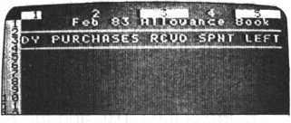

We’ve now finished setting up the title and format for our FALC table. Notice our title uses lines one to four, so our column information will start from line five. In other words, line five is used for the first day of the month, February in our case.

Now we’re ready to input our monthly allowance data into our FALC table.

1. Let’s fill in the table

We already learned how to input data into a FALC table. There is also another method. Instead of using the W command as we learned earlier, we can use an expression during the COMMAND prompt mode.

Let’s try an example. Column 3, named RCVD, contains the money received per day. Obviously, we can use the W command in either the automatic mode or free format mode to fill in this column. This time, change to the COMMAND prompt mode and type in 4 0 = m 5,3 RETURN. Look at column 3. A “40” is placed in the fifth line of column 3. In our example, it’s the money received for the first day of February. This style of input is called “matrix designation.” A breakdown of a matrix designation command follows.

expression = m line number , column number

|  |  |
| --- | --- |
| Parameter | Meaning |
| expression | This is the input data. |
| zz | Necessary separator |
| m | Denotes the matrix designation |
| line number | Line number of target field |
| , Necessary separator | |
| column number | Column number of target field |

When using a matrix designation type command, be sure the line number precedes the column number. Also note the equal sign and comma are always necessary.

Try several on your own. Verify that your data goes where you targeted it to go.

When you’ve become familiar with this command, we’ll put valid data in our allowance account book. Notice we’ll only put data in the first four columns, namely DY, PURCHASES, RCVD, and SPNT. In this instance, this is the data we’ve collected from day to day during February. The fifth column, LEFT, is calculated later.

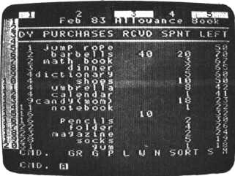

1. Calculating the fifth column, LEFT

To find out how much money we have LEFT, we want to add the ReCeiV- eD money to the money LEFT, if any. Then we want to subtract the amount we SPeNT from the money LEFT. The result is placed in the money LEFT column.

FALC allows us to do this manually with a matrix designation command.

We’ll go through one day’s calculations. Assuming we have 20 in column 4 of line 6 (SPNT column), 40 in column 3 of line 6 (RCVD column), and 50 left over from the previous day which was the first day of the month (LEFT column of line 5). We’ll determine the money LEFT on the second day of February. The answer, naturally, is placed in column 5 (LEFT column) of line 6, and takes two operations. Type in:

50 + 40 = m6,5 RETURN

This adds the money ReCeiVeD on February 2nd (line 6) to the money left over from February 1st (line 5) and places the result in column 5 of line

6.

Now assume we spend 20 on February 2nd. So we’ll need to subtract 20 from 90, or the money LEFT in column 5 of line 6. That’s right, this is the amount we just calculated (money ReCeiVeD on February 2nd added to money LEFT from February 1st). Type in:

90— 20 = m6,5 RETURN

The LEFT column of line 6 now contains the amount of money left at the end of February 2nd.

There is an easier way. Rather than look at the table to extract numbers visually, and then use them in calculations, we can ignore the values and concentrate on column and line numbers. The previous expression,

50 + 40 = m6,5, can also be expressed as:

m5,5 + m6,3 = m6,5 RETURN

Likewise, the expression, 90-20 = m6,5, can be expressed:

m 6,5 - m6,4 = m6,5 RETURN

See how these work? They use the matrix designation of each field as parameters for the expression. The values are ignored, making it much easier for you. Try it. Complete your allowance book day by day. You’ll probably find this method easier than manually looking up values in the table for your calculations.

1. Saving your allowance book

After completing your allowance book, be sure to save it on cassette tape using the P command. Refer to section 3.8 if you’ve forgotten how. You can now start a library of FALC tables containing a history of your allowance.

1. **Telephone Book Example**

Our next example is for the entire family. Everyone can use a personalized telephone book. With FALC, everyone can have their own. Anyone who wants their own telephone book has to just follow this example. They can save it on their own cassette tape and retrieve it anytime for modification.

1. Telephone book contents

Again, as with our allowance book example, we need to think about the contents of our telephone book.

|  |  |
| --- | --- |
| Information | FALC Table Remarks |
| • title | * Input “My Telephone Book” in the first line of the screen. This will be the title for our book. Instead of “my”, use your own name. * The title is used to distinguish this table from the allowance example, another telephone book, or any other table. |
| • reference number | * We’ll use a reference number in the first column of our telephone book. Along with being able to know how many telephone numbers we have, it is useful when we change the order or need to reference a particular number. * Two digits will suffice. Let’s call it NO. |
| • name | • This column is obviously necessary. It should accommodate a long enough name; we’ll allocate a maximum of eleven characters and call it NAME. |
| • telephone number | • Our longest telephone number will be twelve numbers, including the hyphen, between the office code and subscriber number. This field will be the third column named TEL NO. |

To summarize, we’ve decided on a telephone book format of three columns of two, eleven, and twelve characters, respectively.

1. How to reorganize the FALC table (N command)

You just turned the switch on and the FALC screen is displayed. It has a width of 56 characters, 66 lines, and eight columns of seven characters each. But for our telephone book, we only require three columns of two, eleven, and twelve characters, a total of 25 characters.

We’ll also want a large capacity book, so we’ll use 99 lines. We went through how to allocate 39 lines in the previous allowance book example using the N command. Go back to it if you’ve forgotten how.

Our next task is to allocate the lengths of the three columns.

1. Press the N key followed by the RETURN key when the COMMAND prompt is displayed on the screen. The message (1)FORMAT(2)HEADER
2. ALL is then displayed.

Three things can be altered using this FALC command, by entering 1, 2 or 3.

|  |  |
| --- | --- |
| Input | Meaning |
| 1 | You can change the column formats i.e. number of characters per column |
| 2 | This tells FALC how many lines our header will take |
| 3 | The size, number of columns and the number of characters in each column can be altered. |

1. Press the 1 key followed by the RETURN key. “f7,7,7,7,7,7,7,7,” is displayed. The cursor blinks under the “f”.
2. Type in f 2 , 1 1 ,12, RETURN to allocate the lengths of our three columns.

Don’t forget to type in the last comma or the beginning “f”. If you’ve input this line correctly, the line above the cursor will change to your new input information and you’ll see the COMMAND prompt.

Two keys points you should be aware of when using the N command.

* The total number of characters in all columns cannot exceed the maximum allocated for the table width.
* You cannot allocate more columns than designated in the table parameters.

(3) Inputting the names of the table and columns

After setting up the table’s format, we’re going to name the telephone book and the columns. Remember, we’re calling this “My Telephone Book”; use your own name instead of “My”. As with the allowance book, we’ll also underline the second and fourth lines to highlight the names of the columns. Remember, we’ve decided to call them NO, NAME, and TEL NO. Use the SHIFT key to input upper case alphabets.

1. Press the W and RETURN key when the COMMAND

prompt is given.

1. Press the CTRL and the E keys simultaneously. This will change FALC to the edit mode.
2. Now type in My Telephone Book followed by the RETURN key.
3. Press the FUNC and the 3 key to change the M5 console to the graphics mode.
4. Press the B key (F key) to draw two horizontal lines. Keep pressing the B key until the first line is drawn. Now press the RETURN key twice and draw the second line. Follow this by another RETURN key. This creates underlines in the second and fourth lines.
5. Press the CTRL and the E keys simultaneously again to change FALC back to the W mode.
6. Press the FUNC and 1 key to return to the alphabet mode.
7. Press the SHIFT and RESET keys at the same time to return to the COMMAND mode.
8. Press the W key when you see the COMMAND prompt.
9. You’ll see the cursor in the first field of the first column. We need to create the headers for each column. To do this, let’s take advantage of one of FALC’s features.
10. Use the CTRL key and the cursor control key to move the cursor to line 3 of column one.
11. Press the CTRL and C keys to change the direction of the cursor 19 move to the right.
12. Type in N O. This is the name of our first column. Now press the RETURN key. Notice the cursor moves to the next column and moves ‘NO’ to the right side of the column.
13. Now type in N A M E followed by the RETURN key. This is the name of our second column.
14. Type in T E L NO followed by the RETURN key. This is the name of our third column.
15. Press the SHIFT and RESET keys at the same time to return to the COMMAND mode.
16. Input telephone book information

Our next step is to input all of our friend’s names and telephone numbers. If you need to review how to do this, refer to section 4.1 (3).

1. Saving our telephone book

After completing our telephone book, be sure to save it on cassette tape using the P command. Refer to section 3.8 if you’ve forgotten how. You can now retrieve it anytime and add or delete names and telephone numbers. If you modify it, remember to save it again.

If you need a very large personalized telephone book, you may find it necessary to allocate one FALC table per letter.

1. Shifting our telephone book information

Look at the information in the second column, NAME. The first characters of all names are irregularly spaced and a bit difficult to read. FALC can easily change this in the W command mode.

1. Press the W and RETURN key when the COMMAND prompt is given.
2. Move the cursor to the second column, NAME. Any line will do.
3. Press the CTRL key and the L key simultaneously.

The name is now shifted over to the left side of the field. Pretty convenient, right? Likewise, the R command will shift the name to the right side of the field. Try it a couple of times. Eventually, shift all the names to the left side of their fields.

1. Sorting the contents of our telephone book

Sorting can be done with the contents of a file to make it easier to read or put into a more logical order. This can be done in many different ways. For example, names can be classified alphabetically while telephone numbers can be grouped by area code. The SORT command does this for you very easily.

Initially, the number of lines is set at 66. If you need fewer or more lines than this, you can reset FALC to the number you require by using the N command. The N command also allows you to delimit the title and header information. This way, sorting is confined to the contents only. As you may have guessed, the N command is used to define the format of our FALC tables.

The first four lines are reserved for the title and column headings. FALC needs this information before it can properly sort our data, so type in N and press the RETURN key. A familiar message will appear at the bottom of the screen.

(1) FORMAT (2) HEADER (3) ALL

Type in 2 and press the RETURN key. It’s now waiting for you to enter the number of lines we want to delimit. If you previously set a value in this parameter, it will be indicated on the screen. If it’s already correct as is, press the RETURN key once more. However, if it is not a 4, we need to change it. If it is not a 4, type in 4, the new value. The old value will remain on the screen as a reminder. Then press the RETURN key.

The COMMAND prompt will appear and the cursor will blink. It is important to note that there are limitations to the values that can be set for FORMAT, HEADER and ALL. In the case of (2)HEADER, the maximum number of lines that can be delimited is 11. If you attempt to use a number greater than 11, the computer will ignore your input and wait for a new value less than 11 and the COMMAND prompt will not reappear until a correct value has been input and the RETURN key is pressed.

When the (2)HEADER option is chosen for the N command, keep the following in mind.

* In general, lines delimited in this way are assumed to be the header and are not treated as ordinary data.
* When using the SORT command, delimited lines are considered to be the header and are not sorted. We’ll go over this command shortly. [1]

1. Eliminating blank lines

We’re getting ready to sort our telephone book, but unless we completely filled up our book with 99 lines, we’re also going to sort blank lines. Unless we somehow delete these lines, FALC will assume we want to sort them with the other data.

This is also true if our table is smaller, say, 66 lines (minimum size). Unless we delete any blank lines at the bottom of the table, they will also be sorted.

The CTRL and D key combination is used to delete lines from FALC tables. Follow the procedure below.

1. Press the W key and then the RETURN key in the COMMAND prompt mode.
2. Using the CTRL and cursor control keys, move the cursor to the bottom line of our telephone book table.
3. If the arrow denoting the cursor direction points down, press the CTRL key and the C key simultaneously. This will change the arrow to point to the right. If the arrow already points to the right, don’t do anything in this step.
4. Press the CTRL key and the D key at the same time. Do you see what happened? The 99th line is deleted. Keep doing this until the last line of data is reached. Don’t delete the last line of information.
5. Press the SHIFT and RESET keys simultaneously to return to the COMMAND prompt mode. We’re all set to learn how to sort our data.

Step 3 is very important. If the arrow points downward, the CTRL and D key combination will not delete any lines. It’ll delete columns instead. A very different result indeed.

If the above procedure is used to delete lines, additional lines can be allocated with the I command. Refer to page 59.

1. Sorting our data

Rather than go into an explanation on sorting data, let’s actually sort

some data. It’s function will become clear, if it isn’t already obvious.

.1. Type in S 0 R T and then the RETURN key in the COMMAND prompt mode.

1. If you have a color TV screen, the color of the FALC screen will be purple.
2. A CONDITION prompt will be displayed. This prompt can be used several ways; in our case, we’ll use it to input the number of the column that we want to sort. So press the 2 key followed by the RETURN key. This tells FALC we want to sort column 2, NAME.
3. An ASCENDING(I) prompt is then displayed. This prompt asks us what kind of sorting to perform. The “1” in parentheses tells us an input of “1” will sort alphabetically in descending order. So type in a 4 followed by the RETURN key. We can also perform other sorting methods.

|  |  |
| --- | --- |
| Input | Sort Type |
| 1 | Alphabetical order (A-Z) # |
| 1/n | Ascending numerical order * |
| 2 | Reverse alphabetical order (Z-A) # ** |
| 2/n | Descending numerical order * ** |

* Use this sorting method when sorting numerically.
* Use this sorting method when sorting alphabetically. ** The ‘2’ may actually be any number except ‘V.

1. The CONDITION prompt will again be displayed. This time, we’ll tell FALC we’ve finished inputting conditions and to sort our data. Press the E key and then the RETURN key.
2. Our data is sorted and displayed on the screen. Simple as that!
3. The screen returns to the COMMAND prompt mode.

Next, let’s sort our table back to its original state. This may be a bit redundant, but you’ll soon be an expert at sorting.

1. Type in S O R T and then the RETURN key in the COMMAND prompt mode.
2. If you have a color TV screen, the color of the FALC screen will be purple.
3. The CONDITION prompt will be displayed.

Press the 1 key followed by the RETURN key. This tells FALC we want to sort column 1, NO, this time.

1. The ASCENDING(I) prompt is then displayed. This time we’ll sort numerically in ascending order. Type in 1 / n followed by the RETURN key.
2. The CONDITION prompt will again be displayed. Press the E key and then the RETURN key.
3. Our data is sorted and displayed on the screen. Simple!
4. The screen returns to the COMMAND prompt mode.

Now that you’re getting good at the sort command, let’s try a little more

complicated sorting procedure. We’ll sort the names alphabetically after

sorting by area code and office code. This time, we’ll give FALC two conditions when the CONDITION prompts are displayed.

1. Type in S 0 R T and then the RETURN key in the COMMAND prompt mode.
2. If you have a color TV screen, the color of the FALC screen will be purple.
3. The CONDITION prompt will be displayed.

Press the 3 key followed by the RETURN key. This tells FALC we want to sort column 3, TEL NO.

1. The ASCENDING(I) prompt is then displayed. This time we’ll also sort numerically in ascending order. Type in 1 / n followed by the RETURN key. When telephone numbers are sorted, only the area code and office code are used for the sort because of the hyphen between the office code and subscriber number. If "1/n” is not used (“1” is used instead), the numbers is treated as alphabetic characters.
2. The CONDITION prompt will again be displayed. Press the 2 key followed by the RETURN key. This informs FALC we also want to sort on column 2, NAME.
3. The ASCENDING(I) prompt will then be displayed. Press the 1 key and then the RETURN key. This means we also want to sort the NAME column in descending order within each set of sorted telephone numbers.
4. The CONDITION prompt will again be displayed. Press the E key and then the RETURN key.
5. Our data is sorted and displayed on the screen.
6. The screen returns to the COMMAND prompt mode.

What happened? We’ve sorted the telephone numbers by area code and office code. Within these sorted numbers, we also sorted the names.

Using FALC, it’s possible to sort up to five nested levels. Sorting within a sorted category that is also sorted within that sorted category, etc. This allows you to get into some pretty complex sorts.

If you forget to type in the slash followed by the letter ‘n’ in step 4, FALC will sort column 1 as if it contains alphabetic characters. Be careful since this may not sort your data the way you desire.

The hierarchy of characters is as follows (lowest to highest):

1. Blanks
2. Miscellaneous symbols
3. Numbers
4. Upper case alphabets
5. Lower case alphabets
6. Graphics characters
7. Inserting more telephone numbers

Earlier, we deleted all the lines we didn’t want to sort with the D command. At this point, we cannot add more telephone numbers because we’ve limited the size of our table. This is easily rectified with the I command.

1. Press the W key and then the RETURN key in the COMMAND prompt mode.
2. Using the CTRL key and cursor control keys, move the cursor to below the header. You can add new lines anywhere except in the header which was delimited by the N command.
3. If the arrow denoting the cursor direction points down, press the CTRL key and the C key simultaneously. This will change the arrow to point to the right. If the arrow already points to the right, don’t do anything in this step.
4. Press the CTRL key and the I key at the same time. This inserts a new line.
5. Fill in the NO, NAME, and TEL NO of the new line using the normal W command format.
6. Move the cursor to where you want a new line inserted and repeat steps 4 and 5. This can continue until the maximum size is reached.
7. When you’ve finished adding more lines and data, press the SHIFT and RESET keys simultaneously. This will get you back to the COMMAND prompt.

A word of caution. In step 3, if you leave the arrow pointing downwards, FALC thinks you then want to add one more column at the cursor position and asks you for the length of the new column. Press the SHIFT and RESET keys simultaneously if this is not what you want to do.

1. The FALC table is larger than what we see on the screen.

The screen can display 20 lines of 29 characters each. Obviously, this is not large enough to contain a large table. Because of this, a part of the table will always be hidden. Yes, hidden, but accessible using the G command. Its format follows:

G Line number, Column number RETURN

The line number and column number have already been discussed. Two precautions: [2]

Look at the illustrations below. They show the screen given the following G commands.

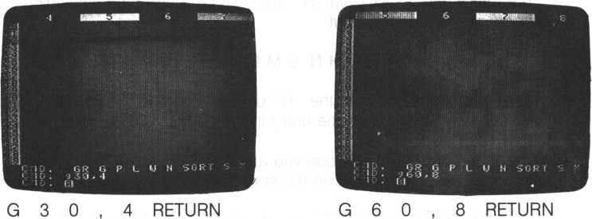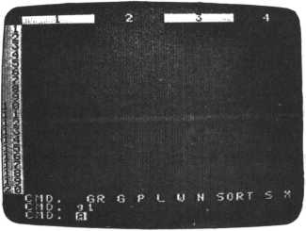

G 1 RETURN

1. Searching for information

It’s possible to search for a particular set of data. For example, we can find a particular telephone number without having to visually look at the entire phone book. This is made possible with the S command.

1. Press the S key and then the RETURN key in the COMMAND prompt mode.
2. If you have a color TV, the screen color will change to purple and a SPECIFY( + ,*,-) prompt is displayed.

Press the 2 key followed by the RETURN key to designate searching of the second column, NAME. You may specify up to 5 columns to search.

1. The CONDITION prompt will then be displayed. This means you should input the information we are looking for. For example, if we want to find “JOHN SMITH”, we would input:

JOHN SMITH* RETURN

The asterisk tells FALC we want any names starting with “JOHN SMITH”. For example, FALC would also find “JOHN SMITHY” with the above command. And because the NAME field contains a maximum of 11 characters and “JOHN SMITH” takes up ten characters (including the space), we could also input:

JOHN SMITH RETURN

There is a space between the “H” of "SMITH” and the RETURN key. Do you see why? It matches the entry in the NAME field exactly.

1. When the name of the person you are searching for is found, only that particular line is displayed on the screen.
2. Press the SHIFT and RESET keys simultaneously. This will get you back to the COMMAND prompt.

A few pointers. Computers still need to be told exactly what to do. They cannot and will not assume anything. Therefore, even if one character is missing from what you want to search for, FALC may not find what you are looking for. One character can make all the difference. Also, if the fields are shifted to the left side with the L command (we went over the L command in section 4.2 (6)), it becomes necessary to use the asterisk as above or input the correct number of spaces between the field and the RETURN key.

Relax if you don’t completely understand the usage of the asterisk. We’ll detail it now.

Simply put, the asterisk is meant to make it easier to search. Instead of specifying exactly our searching pattern, we just need to use an asterisk and a subset of the name we are searching for. For example, in our previous example of searching for “JOHN SMITH”, we specified an asterisk after the “H” of “SMITH”. This tells FALC to search for anything beginning with “JOHN SMITH”. It doesn’t matter how many characters follow “JOHN SMITH”. Anything satisfying this criteria is pointed out to us by FALC. Likewise, we could have also specified:

♦ JOHN SMITH* RETURN

This would search for a name containing “JOHN SMITH” anywhere in the name. For example, “OJOHN SMITH” or “JOHN SMITHY” would satisfy our search criteria. We could have also used:

♦ SMITH[3] RETURN

or

J * S M I T H * RETURN

Naturally, if our names were shifted over to the right side of the column, we could omit the rightmost asterisk.

We could have also used a question mark instead of an asterisk. A question mark is unlike an asterisk in that it looks for a name of exactly the same length; the number of question marks added to the number of characters in the name equal the length and value of the searched for field.

This time, let’s search in column 3, TEL NO. We’ll look for a telephone number containing the office code “678” in digit positions 4 through 6 (counting from the left).

1. Press the S key and then the RETURN key in the COMMAND prompt mode.
2. If you have a color TV, the screen color will change to purple and a SPECIFY( + ,*,-) prompt is displayed.

Press the 3 key followed by the RETURN key to designate searching of the third column, TEL NO.

1. The CONDITION prompt will then be displayed. This means we should input the information we are looking for. Input:

????678???7? RETURN

The question marks tell FALC we are searching for a number containing any three characters and a “678” followed by any five characters. We could have also input:

If we had wanted to look for a number with an area code of “408” and a subscriber number of “1111”, we would have input:

408-??? - 1111 RETURN

or

* 4 0 8 * 1 1 1 1 RETURN

1. Press the SHIFT and RESET keys simultaneously. This will get you back to the COMMAND prompt.

If you want to search for another field, start over from step 1.

You’ve probably noticed the FALC screen only displays the data matching our search criteria. All other information is not displayed. To display the remaining data again, perform the following:

1. Press the S key and then the RETURN key in the COMMAND prompt mode.
2. If you have a color TV, the screen color will change to purple and a SPECIFY( + ,*,-) prompt is displayed.

Press the 1 key followed by the RETURN key.

1. The CONDITION prompt will then be displayed. Type in an asterisk followed by a RETURN key. As you suspect, this actually tells FALC we want to search for everything in our table. Thus, our entire table is displayed.
2. Press the SHIFT and RESET keys simultaneously. This will get you back to the COMMAND prompt.
   1. **Student Exam List Example**

Let’s determine the contents of our student examination list.

|  |  |
| --- | --- |
| Information | FALC Table Remarks |
| • title | • Input “Student Exam-Name” in the first line of the screen and it is the title for our table. Use your name instead of “name”. |
| exam time | * This column contains the name of the month an examination is taken. It’ll be called DATE. * We’ll allocate this column to be eight columns wide. The format will be MM/DD/YY. |
| • tested subjects | * We’ll allocate five columns for five tested subjects. In our case, we’ll use MATH, ENGL (English), CHEM (Chemistry), ART and PHIL (Philosophy).   Let’s use the names in upper case letters for our column names.   * Each column will be four columns wide. |
| • average score | * This column will contain the average score for the five tested subjects above. * This column will be five columns wide and called AVG. |
| • total score | * This column contains the total score for all five tested subjects. * This column will be five columns wide and called SUM. |

To summarize, we’ve determined we need a table of eight columns of 38 characters divided into widths of 8, 5, 5, 5, 5, 5, 5 and 5 characters, respectively.

1. Changing the table format

In our previous examples, we used the N command to format our tables. Here, let’s see how we can do it in the W command mode with the F sub-command.

When the power is first turned on, or FALC screen comprises 66 lines of 56 characters each. This doesn’t fit our requirements, so let’s change it.

1. Press the W and RETURN keys when the COMMAND prompt is given.
2. Look for the cursor, confirm it’s in column 1 (any line). We’ll later call this column DATE.
3. Press the CTRL and F key at the same time. This let’s FALC know we want to format the table. Look for the LENGTH prompt.
4. Press the 8 key followed by the RETURN key. See what happened? The first column is reformatted be to eight characters wide.
5. Press the CTRL key and the — cursor control key once to move the cursor to the next column.
6. Repeat steps 3 through 5 for all eight columns. Obviously, step 4 requires a value specific to each column.

A few helpful hints. When using the F subcommand, the cursor can reside on any line of the column. But restructuring of a column cannot happen if a field is in the process of being filled in. Also, as with the N command, the total number of characters in all columns cannot exceed the table parameter information.

1. Checking the table format

Now that we’ve reformatted our table, let’s verify what we just did.

1. Insure we are still in the W command mode. If not, press the W and RETURN keys when the COMMAND prompt is given.
2. Look at the list of characters near the bottom of the screen. This lists all the subcommands we have available in the W command mode. The “CTRL” to the left of the list indicates we need to press the CTRL key at the same time as any letter invoking a subcommand.
3. Press the CTRL key and the S key simultaneously. This informs FALC we want to know the scale of the table. Look at the column numbers again. They’ve changed. They now display the length of each field.
4. Press the CTRL key and the S key simultaneously again. This displays a ruler used to measure the length of any field or table. Notice each ten character interval displaces an extra character field.
5. Press the CTRL key and the S key at the same time again. This will bring the screen back to our original display of column numbers. Steps 3 through 5 can be repeated endlessly; the three sets of information will always be consecutively displayed upon repetitive invocations of the S subcommand.
6. Filling in the examination list

We’re about ready to fill in the table. But first we need a header. This

time, we don’t need to leave the W command mode.

.1. Press the CTRL and E keys simultaneously. This changes FALC to the edit mode.

1. Type inStudentExams followed by the RETURN key.
2. Press the FUNC and the 3 key to change the M5 console to the graphics mode.
3. Press the B key (F key) to draw two horizontal lines. Keep pressing the B key until the first line is drawn. Now press the RETURN key twice and draw the second line. Follow this by another RETURN key. This creates lines in the second and fourth rows.
4. Press the CTRL and the E keys simultaneously again to change FALC back to the W mode.
5. Press the FUNC and 1 keys to return to the alphabet mode.
6. Press the SHIFT and RESET keys at the same time to return to the COMMAND mode.
7. Press the W key when you see the COMMAND prompt.
8. You’ll see the cursor in the first field of the first column. We need to create the headers for each column. To do this, let’s use a cursor control key.
9. Use the CTRL key and the cursor control key to move the cursor to line 3 of column 1.
10. If the cursor direction arrow at the lower left of the screen is pointing downward, press the CTRL and C keys to change the direction of the cursor to move to the right. If the arrow already points to the right, don’t do anything in this step.
11. Type in D A T E. This is the name of our first column. Now press the RETURN key. Notice the cursor moves to the next column and moves DATE to the right side of the column.
12. Type in M A T H followed by the RETURN key. This is the name of our second column.
13. Type in E N G L followed by the RETURN key. This is the name of our third column.
14. Type in C H E M followed by the RETURN key. This is the name of our fourth column.
15. Type in A R T followed by the RETURN key. This is the name of our fifth column.
16. Type in P H I L followed by the RETURN key. This is the name of our sixth column.
17. Type in A V G followed by the RETURN key. This is the name of our seventh column.
18. Type in S U M followed by the RETURN key. This is the name of our eighth column.
19. Press the SHIFT and RESET keys at the same time to return to the COMMAND mode.

Our student examination list table is now completely set up. The next

step is to fill it in with the student’s score. We’ve already gone over how to

do this several times. If you need a review, refer to pages 33- 34 or 49.

Be sure to save your table in one of the memories with the P command.

Also, save your table on cassette tape. It’s easy to accidently turn off your

M5 system and erase all your hard work. Refer to sections 3.8 for a review.

Your table should look similar to the table below.

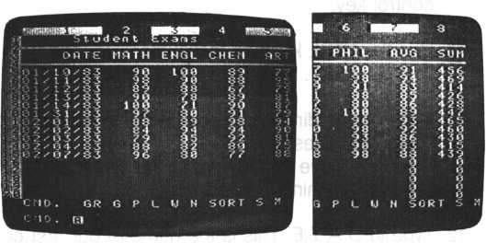

All-dates will be displayed in the MM/DD/YY format.

1. Setting the header length

Similar to previous examples, set the length of the table using the N command. If you can’t remember how, refer to section 4.2 (7). If this is not done, our following calculations may be incorrect. In other words, header information will be used in our calculations.

1. Calculating test scores

First, let’s find the total test scores for each line (remember, our test scores reside in columns 2 through 6). Return to the COMMAND prompt mode and input the following command.

C2 + C6 = /C8 RETURN

This expression tells FALC to sum up columns 2 through 6 and put the sum in column 8. This operation affects every line except the header. Recall that column 8 is called SUM and contains the total of all test scores per line.

The slash, informs FALC to sum from columns 2 through 6, i.e. column 2 + column 3 + column 4 + column 5 + column 6. If the slash were missing, FALC would simply add column 2 and column 6 together, or column 2 -t- column 6. If you didn’t want to add in the column direction, you could instead use “R” instead of “C” to designate a row. For example,

R5 + R8 = /R9 RETURN

The above expression adds all values in rows 5 through eight and puts the answer in row 9. Row 9 of each column will then contain the sums of rows 5 through 8. Pretty convenient, don’t you think?

Next. Let’s calculate the average of the scores of all five subjects. The answers will go into column 7, named AVG. Be sure you’re in the COMMAND prompt mode and input the following expression:

C 8 / 5 = C 7 RETURN

Do you understand why? FALC takes the total scores from column 8, divides them by 5 (five tested subjects), and places the answers in column 7, AVG.

By the way, in division, all numbers greater than five are rounded up. If we want numbers to the right of the decimal point, look at the following expression.

C8/5 = / C 7 . x . y RETURN

where x = 0 : round down

1. : do not round up nor down
2. : round up

y = number of characters to the right of the decimal point (decimal point also takes up one character)

For example,

C8/5 = / C7.0.2 RETURN

means we want to take column 8, divide it by 5 and put the result in column 7. The answers will always be rounded down with one digit to the right of the decimal point.

Several fine points you should be aware of when using these types of commands:

* . 1 . 1 is the default value
* Similar to specifying columns, you can also specify rows. Every number in the rows will be affected. Try it out.

There’s also another way. FALC has several functions denoted by keywords used for calculations. Let’s look at an example.

AVEC2,6 = C7.1.1 RETURN

You’re already familiar with the portion to the right of the decimal point. On the left, “AVE” informs FALC we want an AVErage of the columns designated between the square brackets, columns 2 through 6 in this case. Do you see how this replaces the two steps we just finished to calculate the average? Instead of having to calculate the total and then dividing by 5, we need to just invoke the AVE function.

FALC has seven different functions, including AVE.

The general case for FALC functions is: function name parameter value1 , value2 , limit = location

|  |  |
| --- | --- |
| • Function Name | Function |
| ADD | Addition of contiguous columns |
| SUB | Subtraction of contiguous columns |
| MLT | Multiplication of contiguous columns |
| DVD | Division of contiguous columns |
| MAX | Maximum value of contiguous columns |
| MIN | Minimum value of contiguous columns |

R if a row is specified C if a column is specified number of first column number of second column

where parameter

value1

value2

limit

location

limits the calculations to a particular line number. This parameter, including the preceding comma is optional and may be omitted.

May either be designated by R—row number C—column number M—matrix designation

Another example. Our exercise to add columns 2 through 6 with the C2 + C6 = ICQ expression may also be expressed as:

ADDC2.6 = C 8 RETURN

Now, rather than continue to work on columns, let’s do some examples of calculating by rows.

It’s handy to know the total, highest, lowest and average scores of each subject. Assuming we have ten rows of data (lines 5 through 15), we’ll total each column and place the totals in line 16.

R5 + R15 = /R16 RETURN or

A D D R 5,1 5 = R16 RETURN.

How about finding the highest score in each subject? We’ll put the answer in row 17.

MAXR5.15 = R 1 7 RETURN

The lowest score may be found by:

MINR5,15 = R18 RETURN

That’s right. The answer will be placed in row 18.

To calculate the average of all test scores within each subject, the following expression will suffice. The answers will be put in row 19.

AVER5,15 = R19.1.2 RETURN

The readability of our test score table will be enhanced if we write HIGHEST, LOWEST, and AVERAGE in the appropriate rows of column 1, lines 17, 18, and 19 in this case.

After doing all this exemplary work, save your table on cassette tape. It’s a good idea to take a break. We’ve gone through some powerful commands. Think about what you’ve learned and how you can apply it in other applications.

1. Analyzing the test score table

We’ll make more use of your test score table. But before we go on, let’s summarize. We entered a list of test scores from five subjects; we know the test score totals and averages for any particular day. We also have the highest, lowest, and average scores per subject.

Remember the S command from section 4:2 (12)7 Here, we’ll approach the S command from another angle. Assume we want to find days when any of our test scores are above 90 points. We’ll discuss it as we go.

1. Press the S key followed by the RETURN key in the COMMAND prompt mode.
2. The SPECIFY( + ,*,-) prompt is displayed. Type in:

2 + 3 + 4 + 5 + 6 RETURN

Before we discuss why these plus signs are used, let’s look at some figures.

Usage of +, *, and - for the S command

|  |  |  |  |
| --- | --- | --- | --- |
| Function | + (or) | * (and) | - (not) |
| Example | A + B | A * B | ( - ) A |
| Shaded portions satisfy column criteria | 00 | 0© | o |

Note: A and B represent defining criteria

Do you understand now why we used plus signs?

Let’s discuss it. Using prose, the figures above can be related to FALC. Assume that we have one or more columns of data. We will eventually define a criteria or condition for each column, e.g. any numbers less than 3 or greater than 90. These conditions are then used as criteria to filter out unwanted data.

But before we define these conditions, we need to define the type of relationship we are looking for between these columns. This brings us back to the expression we just input and the previous illustrations.

Look at the illustration and the following legend.

+ given one or more columns of data, any row containing data satisfying the criteria of ANY of the columns is displayed.

* given one or more columns of data, any row containing data satisfying the criteria of ALL columns is displayed.

- any column number preceded by a minus sign will search for data NOT satisfying the criteria for that particular column

Since we used plus signs in our previously input expression, it indicates we want to find rows satisfying our conditions in ANY column; in our case, columns 2, 3, 4, 5, or 6. Any row containing any column data that satisfies its conditions for that row is displayed. .Similarly, if we had used an asterisk, “*”, instead of plus signs, we would be searching for rows satisfying ALL conditions for columns 2, 3, 4, 5, and 6. A maximum of five columns can be searched simultaneously with this type of expression.

1. We’ve been discussing elusive conditions. What are they? For our test score table, remember we are searching for days that found us witti any test score(s) higher than 90. We should now see the number 1 followed by a CONDITION prompt. The number denotes column 1; the CONDITION prompt is asking us for a condition for column 1. And since we are looking for test scores greater than 90, type in > 9 0 followed by a RETURN key.
2. A 2 followed by a new CONDITION prompt is displayed. FALC is asking us for column 2 conditions. Repeat step 3 for each column.
3. All days that have any test score over 90 will now be displayed on the FALC screen!

In step 3, we used the “greater than sign’’, FALC also offers a complete set of comparison operators. Any in the table below can be used identically to “>”.

|  |  |  |
| --- | --- | --- |
| Operator | Usage | Remarks |
| > | > number | Greater than the specified number. |
| < | < number | Less than the specified number |
| — | = number | Equal to the specified number' |
| > = | > = number | Greater than or equal to the specified number (“ = >”) cannot be used) |
| < = | < = number | Less than or equal to the specified number (“ = < ” cannot be used) |

Some examples. Press the S key followed by the RETURN key in the COMMAND prompt mode prior to each of the following examples.

1. Find scores between 85 and 90 in the ENGL column (column 2).

Type in:

2 * 2 RETURN for the SPECIFY( + ,*,-) prompt

>=85 RETURN for the 2 CONDITION prompt

<=90 RETURN for the second 2 CONDITON prompt

1. Search for scores over 90 in the CHEM and ART columns (column 3). Type in:

4 + 2 RETURN for the SPECIFY( + ,*,-) prompt

>90 RETURN for the 4 CONDITION prompt

>90 RETURN for the 2 CONDITION prompt

1. Search for average test scores not below 77.6 for all five subjects. Type in:

- 7 RETURN for the SPECIFY( + prompt

< =77.6 RETURN for the 7 CONDITION prompt

1. Graphing our test score data

With FALC, we don’t need to settle for just table data. We can also quickly have FALC make graphs for us with the GR (graph) command. Basically, it takes our data, asks us for a maximum value, and then graphs it. Let’s look at what it can and cannot do.

* It can graph up to up to five columns of data in the same graph.
* It is limited to 20 rows of data (excluding header).
* The column header in the second from the bottom line of the header is displayed as the graph title.
* FALC will automatically assume column 1 is line header information and is not graphed. This is the DATE column in our example.
* Multiple numbers of graphed columns are delineated in different colors, and always start from data in column 2 onward.
* The scope of a graph can be easily changed.

Let’s go through graphing one column of data. How about column 2, MATH?

1. Type in G R followed by the RETURN key in the COMMAND prompt mode.
2. A NUMBER OF COLUMNS prompt will be displayed. Remember, column 1 is never graphed. So if a 1 is input, FALC will graph one column, namely, column 2. In this case, column 2 is MATH. Yes, that’s the one we want. So press the 1 key followed by the RETURN key.
3. A MAX prompt is now displayed. FALC is asking for the maximum scale of our graph. Assuming 100 is the highest test score possible, type in

1 0 0 followed by the RETURN key.

1. The screen will change to a graph of column 2. Simple as that, we can visually appreciate our test score data.
2. If you want to print out your graph data, press the 1 key followed by the RETURN key.

Graphing is limited to column 2 onward. Therefore, if you want to only graph another column, you’ll first need to transfer that data to column 2 with the M command. It’ll be discussed in detail later.

1. Enhancing readibility of our exam test table

At this point, we’ve done all we want to do with our exam test data. Before we finish, let’s make our table a little easier to read. We’ll draw some vertical and horizontal lines to delimit the total and average scores. The method to draw horizontal lines follows:

1. Press the W key followed by the RETURN key in the COMMAND prompt mode.
2. If the cursor direction pointer at the lower left of the screen is pointing to the right, skip this step. Otherwise, press the CTRL key and the C key at the same time to change the cursor direction to point to the right.
3. Move the cursor to the beginning of the line where the horizontal line is to be drawn.
4. Press the CTRL key and the I key simultaneously. A new line will be allocated for you.
5. Press the FUNC key and the 3 key at the same time. This changes the keyboard to the graphics mode.
6. Keep the E3 key (F key) pressed until the line is drawn.
7. Repeat steps 3 through 6 for each new line.

Let’s go over drawing of vertical lines:

1. Press the W key followed by the RETURN key in the COMMAND prompt mode.
2. If the cursor direction pointer at the lower left of the screen is pointing downward, skip this step. Otherwise, press the CTRL key and the C key at the same time to change the cursor direction to point downward.
3. Move the cursor until the left portion rests where the vertical line is to be drawn.
4. Press the CTRL key and the I key simultaneously.
5. A LENGTH prompt is displayed. This is actually asking you for the length of a new column (which will be our vertical line). Enter a 1 key and then the RETURN key.
6. Press the FUNC key and the 3 key at the same time. This changes the keyboard to the graphics mode.
7. Use the graphics characters HI.Q.H, □ , E , EB , ED , □ , EB . and □ to draw and link this vertical line to existing horizontal lines.
8. Repeat steps 3 through 7 for each new vertical line.

An exception arises when you want to draw a line to the right of the

rightmost column. Use the following. It’ll eventually lead you back to the

previous sequence.

1. Press the W key followed by the RETURN key in the COMMAND prompt mode.
2. If the cursor direction pointer at the lower left of the screen is pointing downward, skip this step. Otherwise, press the CTRL key and the C key at the same time to change the cursor direction to point downward.
3. Move the cursor until the left portion rests just to the right of the rightmost column (next column).
4. Press the CTRL key and the I key simultaneously.
5. A LENGTH prompt is displayed. Enter the length of the last column.
6. Return to the COMMAND prompt mode by pressing the SHIFT and RESET keys simultaneously.
7. Press the M key followed by the RETURN key in the COMMAND prompt mode.
8. A FROM prompt is displayed. Press the C key followed by the number of the newest column (in our test exam example, it is now 9). Then press the RETURN key.
9. A TO prompt is displayed. Press the C key followed by the number of the old rightmost column (in our test exam example, it is 8). Then press the RETURN key. Notice this number is always one less than in step 8.
10. Move the cursor to the last column with the CTRL and the — cursor control key.
11. Press the CTRL and F keys at the same time.
12. Press the 1 key followed by the RETURN key after the LENGTH prompt is given.
13. This changes the length of the last column to 1 character. Perfect for our new vertical line.
14. Go back to page 77. This reviews drawing of a vertical line.

Be sure to save your table in one of the memories with the P command. Also save it on cassette tape.

1. M command (Move command)

We used the M command briefly in the previous sequences to draw a vertical line to the right of the rightmost column. We’ll now give some generalities as well as some limitations of the M command.

The M command is meant to move part of a table to another location.

The contents to be moved can be columns (denoted with a “C”) or rows (denoted with a “Ft”).

The general procedure follows.

1. Press the W key followed by the RETURN key in the COMMAND prompt mode.
2. A FROM prompt is displayed. So we need to specify the parts of the table to be moved by specifying the upper left corner and the lower right corner of the portion to be moved. Notice these two parameters make up the boundaries for a rectangle. This rectangle is the part of the table to move. There are several ways to specify the area to move.
3. By row number and column number—notice the R key in both parameters

R row number 1 , column number 1 , R row number 2 , column number 2

Where • row number 1 is the upper left corner’s row number

* column number 1 is the upper left corner’s column number
* row number 2 is the lower right corner’s row number
* column number 2 is the lower right corner’s column number

Note: Column number 1, row number 2 and column number 2 are

optional. If these are omitted, the entire row is moved. When using this format, omit all commas.

1. By column number and row number—notice the C key in both parameters

C column number 1 , row number 1 , C column number 2 , row number 2

Where • column number 1 is the upper left corner’s column number

* row number 1 is the upper left corner’s row number
* column number 2 is the lower right corner’s column number
* row number 2 is the lower right corner’s row number

Note: Row number 1, column number 2 and row number 2 are optional.

If these are omitted, the entire column is moved. When using this format, omit all commas.

1. A TO prompt is displayed. Here, we need to specify the destination of the area to be moved. Again, as in step 2, we need to specify the upper left corner and the lower right corner. Refer to step two for the formats. The type of input for the FROM prompt and the TO prompt do not need to be identical. However, to begin with, enter the same type of format for both. Learn how they work. Then practice mixing the row and column types. Also practice leaving out the latter three parameters. Practice inputting a complete specification for the FROM prompt, but only specify the row or column in the TO prompt. Utilize the flexibility inherent in the M command. This may become one of your most useful commands.
2. If the input for steps 2 and 3 are entered correctly, the part of the table you want moved will be copied to your specified destination.

When using the M command, heed the following fine points. Try them out. These permutations of the M command make it even more flexible and useful.

* If the size of the area specified for the FROM prompt is larger than the area of the TO prompt, the portion of the moved area exceeding the TO prompt size is not moved.
* If the size of the area specified for the FROM prompt is smaller than the area of the TO prompt, only the data specified in the FROM prompt is moved. The other parts of the area specified in the TO prompt are not changed.
* Data already residing at the destination will be erased.

1. More Graphing Hints

We went over graphing of column 2, MATH, earlier. And because FALC begins graphing from column 2, graphing of column 2 posed no problems. However, what do we do to graph, say, only column 5? Easy enough. Let’s go through an example. Indeed, we’ll make a graph of only column 5, ART.

1. Press the W key followed by the RETURN key in the COMMAND prompt mode.
2. Move the cursor to the second column by pressing the CTRL and — or — cursor key at the same time.
3. If the cursor direction pointer at the lower left of the screen is pointing downward, skip this step.

Otherwise, press the CTRL key and the C key at the same time to change the cursor to point downward.

1. Press the CTRL key and the I key simultaneously.
2. A LENGTH prompt is displayed. Enter the length of the column to be copied. The length of column 5 is four characters wide, so enter a 4 followed by the RETURN key.
3. Return to the COMMAND prompt mode by pressing the SHIFT and RESET keys at the same time.
4. Press the M key followed by the RETURN key.
5. A FROM prompt is displayed. Press the C and 5 keys. This tells FALC we want to copy column 5. Now press the RETURN key.
6. A TO prompt is displayed. Press the C and 2 keys. FALC interprets this to mean column 5 will be copied to column 2 which is the column we just created with the I subcommand. Do you see the information from column 5 now in column 2? Press the RETURN key.
7. When the COMMAND prompt is displayed, press the G , R and RETURN keys.
8. A NUMBER OF COLUMNS prompt will appear. Enter a 1 key followed by the RETURN key. This indicates we want to graph only one column. And since FALC begins graphing from column 2, we end up graphing the information from column 5.
9. After the MAX prompt appears, enter 1 0 0 and a RETURN key. This is the maximum score for our ART projects.
10. Presto! A visual aid is created.
11. To graph any other single column, start over from step 6. In step 8, instead of entering a 5, enter the number of the column you want to graph. Try it out.
12. Unless you want to retain column 2 (remember, it has redundant information), delete it with the D subcommand in the W command mode. Don’t forget to have your cursor direction arrow at the lower left of the screen pointing downward.

All very easy and useful. We hinted earlier we can graph more than one column concurrently. With a color TV, the columns are highlighted with different colors. On a black and white or green monitor, it’ll show up in different shades. As before, this is done with the GR command. Rather than entering a 1 when the NUMBER OF COLUMNS prompt is displayed, enter the number of columns you want to see simultaneously displayed on a graph. Look at the table below.

NUMBER OF COLUMNS

|  |  |  |
| --- | --- | --- |
| Prompt input |  | Columns graphed |
|  | 1 | 2 |
|  | 2 | 2,3 |
|  | 3 | 2, 3,4 |
|  | 4 | 2, 3, 4, 5 |
|  | 5 | 2, 3, 4, 5, 6 |

As suggested by the table, a maximum of five columns can be graphed at one time. Also notice since more than one column can be graphed simultaneously, the MAX prompt requires a value that can accommodate the sum of all graphed columns. In our test score example, we would enter 300 if graphing three columns.

I

**Chapter 5 More FALC Commands**

By now, you’re probably getting to be an expert at FALC. Are you asking, ”ls this all?” Simply put, no. FALC offers to interested users exciting, advanced features that simplify operation.

**5.1. The Notion of a Command String**

The COMMAND prompt is very familiar to us; each time, we responded with one command response. Actually, several commands can be entered at the same time to create a “command string.” All the commands that were possible in the COMMAND prompt mode are still permitted. FALC will then execute each command sequentially. But we need to remember several qualifiers.

* Insert a semicolon between each command.
* The maximum number of characters in one command string is 60.
* If the W command is inserted in the command string, it must be the last command.

As you’ve guessed by now, the semicolon is interpreted by FALC to be a pseudo RETURN key.

1. Retrieving and displaying some FALC tables

An example. Retrieve two FALC tables called TEST from cassette tape, then display the table from memory number

1. Input both commands in a command string when the COMMAND prompt is given; see the following command string.

G ; TEST ; G ; . 1 RETURN t t

Pseudo RETURN key Actual RETURN key

I

1. Manipulating several columns of data

Here, in our next example, we’ll perform several functions sequentially.

1. Write the sum of the 2nd column through the 6th column into the 8th column.
2. Write the average of the 2nd column through the 6th column into the 7th column. Express it to one decimal place.
3. Write the sum of the 5th line through the 15th line into the 16th line.
4. Place the cursor at the 1st column of the 16th line using a W command.

Follow along with the command string below.

ADD [C 2,6] = C 8 ; A V E [C 2,6] =

C7.1 . 2 ; R 5 + R1 5 = / R 1 6 ; W 1 6 , 1 RETURN

Remember, when the W command is used, it must be the last command in the command string.

1. Call and retrieve some information from a table

In this example, retrieve the two FALC tables called TEL from cassette tape, display the table from memory number 2, and retrieve the line having SMITH in column 2 using the S command. Then display the line. (Remember our telephone book example?). Input this desired function in a command string when the COMMAND prompt is given.

G;TEL;G;.2;S;2;SMITH* RETURN

**5.2. Programmed Functions**

You may have heard yourself mutter, “This sure is tedious, why doesn’t FALC allow me to save and reuse several sequences of commands that I use over and over?” Obviously, FALC does provide very nicely for this. For example, when a new name is added to your telephone book (see Chapter 4.2), it would be convenient to have a function to both add the name and resort the telephone book. Perhaps you took a fancy to some frequently used command strings. Or perhaps you frequently use a complex arithmetic expression. In any case, you can specify up to five functions consisting of commands or command strings.

1. Setting up functions

Before any functions can be used, the correct tables that correspond to each set of five programmed functions must be loaded in memory, i.e. the two tables in memory numbers 1 and 2. (If your M5 has 32K bytes of memory, tables in memory numbers 1 through 9 are applicable.) Let’s go through a couple of sequences to learn what functions are all about.

1. Be sure the applicable tables are either in memory or displayed on the screen.
2. 'Press the W and RETURN key when the COMMAND prompt is given.
3. Press the CTRL and U keys simultaneously. Your table will be replaced by another FALC table. Implicit in the FALC table is five blocks of three lines each, i.e. lines 1 to 3 form one block, lines 4 to 6 form another, and so on. These five blocks correspond to your five functions, each containing a command string.
4. Both commands, command strings and arithmetic expressions may be set up as functions, but let’s limit ourselves to commands and command strings for now; arithmetic expressions are treated a little differently and will be discussed separately later. So enter a command or command string in the first block for the first function. When entering commands, use the semicolon to separate what would normally be entered by yourself. For example, when using the GR (graph) command, enter G R followed by a semicolon, followed by the number of columns to graph, followed by the maximum value for your graphs.

G R ; 1 ; 1 0 0 RETURN

graphs one column with a maximum of 100. You’re limited to 87 characters per function. When one line is filled, the cursor automatically moves to the next line.

1. Make sure the function is specified correctly and press the RETURN key. The cursor will automatically move to line 4, which is the next block.

Enter the next function.

1. Repeat steps 4 and 5 until all five functions have been specified. If you have fewer than five, simply press the RETURN key again. Once five functions have been entered and the RETURN key is pressed, FALC will return you to the W command mode.

Follow the sequence on the next page to glimpse and verify the functions. Ignore steps 1 and 2 if the correct tables are already loaded in memory.

1. Be sure the applicable, tables are either in memory or displayed on the screen.
2. Press the W and RETURN key when the COMMAND prompt is given.
3. Press the CTRL and U keys simultaneously. The first function is displayed.
4. Press the RETURN key. The next function is displayed.
5. Repeat step 4 until all functions have been displayed. When all functions have been displayed, FALC will return you to the W command mode.

It’s just as easy to edit your functions. Again, if the correct tables are

already loaded, ignore steps 1 and 2.

1. Be sure the applicable tables are either in memory or displayed on the screen.
2. Press the W and RETURN key when the COMMAND prompt is given.
3. Press the CTRL and U keys simultaneously. The first function is displayed.
4. If you desire to edit this function’s command string, e.g. correct, delete, insert, etc., do so as with the edit mode you learned earlier.
5. Press the RETURN key. The next function is displayed. If desired, also edit this next function.
6. Repeat steps 4 and 5 until all functions have been displayed and/or edited. FALC will then return you to the W command mode.

A few pointers.

* Always begin specifying functions from the first line of each three line block.
* If you want to completely substitute a function with another, it is easier to first press the CTRL and X keys at the same time to delete the old function’s command string.
* If a function is deleted or left blank, later functions cannot be accessed. Unless you don’t intend to further access later functions, don’t leave a function blank. For example, if function 3 is left blank, functions 4 and 5 are not accessible.
* When this set of tables is stored on cassette tape (using the P command), this set of functions is also stored on tape. So the next time these tables are retrieved (using the G command), these five functions are also retrieved.
* Be sure your console is in the alphabet mode.
* Remember that when a set of FALC tables are retrieved from cassette tape, any tables currently in memory are overwritten, i.e. you’ve lost them unless they’ve also been saved on cassette tape.

1. Using these functions

OK. Now how do you use these functions?

1. Be sure the applicable tables are either in memory or displayed on the screen.
2. Be sure you’re in the COMMAND prompt mode.
3. Simply type in the key followed by the number of the function that you want to execute. Now press the RETURN key. The example below will execute function number 3.

3 RETURN

For a primer, enter the graph (GR command) example below and try it for

a quick taste.

If

G R ; 2 ; 2 0 0 RETURN is specified as function 3, entering

3 RETURN

in the COMMAND prompt mode will cause columns 2 and 3 to be graphed with a graph maximum of 200.

1. The commands in the command string for the desired command function will be executed sequentially. If a function is illegally specified, you'll hear a “beep”and FALC will return you to the COMMAND prompt mode.
2. Arithmetic programmed functions

Wouldn’t it be convenient to have a set of powerful arithmetic functions to quickly assess “on the fly” the impact of any new data? Perhaps given a few changes in one of our FALC tables, how does a recomputation affect the rest of the table? Or our results? Surely this will save us time and possibly some money as well. This leads us to arithmetic expressions (that can also can be referred to as functions) that can be randomly accessed to recompute our table data.

Before we go into how to specify our arithmetic functions, some important pointers. [4]

Let’s proceed.

1. Be sure the applicable tables are either in memory or displayed on the screen.
2. Press the W and RETURN key when the COMMAND prompt is given.
3. Press the CTRL and V keys simultaneously. Recognize it? Yes, this is the same five blocks allocated for your command functions. But by typing in a CTRL V key combination, FALC will check each function to ensure it is an arithmetic function. So if you have commands in any of these function blocks, a “beep” will be heard when a RETURN is pressed. This informs you the function is not a legal arithmetic function and must be re-entered. Yes, the command functions we discussed earlier use the same space as arithmetic functions. The difference between the CTRL U key combination and the CTRL V key combination is that the CTRL V combination will check for a legal arithmetic expression.
4. Enter the arithmetic expression in lines 1 to 3 for the first arithmetic function. You’re limited to one arithmetic expression (one equal sign) of up to 87 characters for each function. When one line is filled, the cursor automatically moves to the next line. Likewise, when one function is finished, the cursor moves to the next function.
5. Make sure the arithmetic function is specified correctly and press the RETURN key. If you’ve inserted an invalid character or have more than one expression, FALC will give you a “beep” and put the cursor at the first character again (so you can start over). Otherwise, the cursor now moves to the second block; enter the next arithmetic function.
6. Repeat steps 4 and 5 until all your arithmetic functions have been specified (up to five). If you have fewer than five, simply press the RETURN

key again. Once five arithmetic functions have been entered and the RETURN key is pressed, FALC will return you to the W command mode.

Follow the sequence below to glimpse and verify the arithmetic functions.

Ignore steps 1 and 2 if the correct tables are already loaded in memory.

1. Be sure the applicable tables are either in memory or displayed on the screen.
2. Press the W and RETURN key when the COMMAND prompt is given.
3. Press the CTRL and V keys simultaneously. The first arithmetic function is displayed.
4. Press the RETURN key. The next arithmetic function is displayed.
5. Repeat step 4 until all arithmetic functions have been displayed. FALC will then return you to the W command mode.

Editing your arithmetic functions? Here again, if the correct tables are

already loaded, ignore steps 1 and 2.

1. Be sure the applicable tables are either in memory or displayed on the screen.

,2. Press the W and RETURN key when the COMMAND prompt is given.

1. Press the CTRL and V keys simultaneously. The first arithmetic function is displayed.
2. If you desire to edit this arithmetic function e.g. correct, delete, insert, etc., do so with the edit mode.
3. Press the RETURN key. The next arithmetic function is displayed. If desired, also edit this next arithmetic function.
4. Repeat steps 4 and 5 until all arithmetic functions have been displayed and/or edited. FALC will then return you to the W command mode.

A few additional pointers.

* If you want to completely substitute a arithmetic function with another, it

is easier to first press the CTRL and X keys at the same time to delete the old arithmetic expression.

* Since these arithmetic functions are treated as part of the set of five functions we went over ealier, they are stored on tape. The next time these tables are retrieved (using the G command), any arithmetic functions are also retrieved. Think a bit before retrieving a new table from cassette tape; once retrieved, the retrieved tables wipe out any tables and functions previously in memory.

(4) Using arithmetic functions

Let’s go over usage of these arithmetic functions. Follow me.

1. Be sure the applicable tables are either in memory or displayed on the screen.
2. Be sure you’re in the COMMAND prompt mode.
3. Press the key followed by the number of the arithmetic function. For example, type

4 RETURN

to access arithmetic function 4. Yes, it uses the same format as command functions.

1. Repeat step 3 to access other necessary arithmetic functions.

The command functions and arithmetic functions are used in the same way. The reason FALC makes a distinction is to allow checking the legality of both types of functions. You tell FALC what type of function (by using a CTRL U combination or a CTRL V combination), and FALC will check it for you before it’s executed.

1. **Test Score Function Example**

Experience is a great teacher. Along this vein, let’s go over an example that shows us how to use arithmetic functions. •Remember our test score example in section 4.3? We’ll also use it here.

To summarize, we have five columns of test scores for five different subjects. Here, we'll sum and average the cumulative scores of all five subjects as well as the sums and averages of each subject. The four sequential arithmetic functions below work nicely.

|  |  |  |
| --- | --- | --- |
| 1. | C2 + C6 = | / C 8 . 1 .1 |
| 2. | A V E [ C 2,6 ] | CM  O  II |
| 3. | R 5 + R 1 5 = | / R 1 6 . 1 . 1 |
| 4. | A V E [ R 5 , 1 5] | = R 1 7 . 1 . 2 |

Don’t forget the specifications for the number of decimal places in the answers. Then to access these arithmetic functions, type in a # followed by the function number. Use them as needed. Look at the screen below.

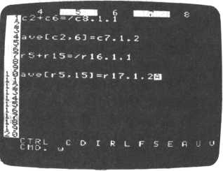

Now look at the screen below to get an idea of what the above expressions accomplish.

I

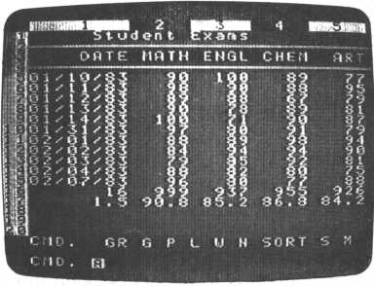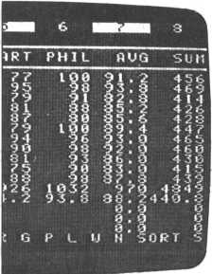

**Chapter 6 Command Quick Reference**

It’s frequently handy to have a table that lists each command and where to look for a description.

Look in the “Mode” column. A W means FALC must be in the W command mode. The operations are then subcommands within the W command mode. An arrow, if listed, shows the cursor direction; it corresponds to the arrow at the lower left of your FALC screen. If COMMAND is listed, it indicates you must be in the COMMAND prompt mode. The “Page” column, obviously, shows you where to look for command descriptions.

(1) Writing into a FALC table

|  |  |  |  |
| --- | --- | --- | --- |
| Function | Mode | Operation | Page |
| Access Write command | COMMAND | W | 27 |
| Enter alphabet mode | W | FUNC ALPHA (1) | 19 |
| Enter graphics mode | W | FUNC GRAPH (3) | 20 |
| Move the cursor | W | CTRL t l | 30 |
| Move the cursor to field | COMMAND | W line, column | 30 |
| Change cursor direction | W l | CTRL C | 29 |
| Change cursor direction | W - | CTRL C | 29 |
| Left justify field | W | CTRL L | 54 |
| Right justify field | W | CTRL R | 54 |
| Delete one character | W | CTRL DEL | 32 |
| Delete one line | W | CTRL X | 32 |
| Delete one column | W 1 | CTRL D | 81 |
| Delete one line | W - | CTRL D | 56 |
| Insert one column | W 1 | CTRL 1 | 81 |
| Insert one line | W - | CTRL 1 | 59 |
| Copy table part elsewhere | COMMAND | M | 79 |
| Enter edit mode | W | CTRL E | 33 |

(2) Using the edit mode

|  |  |  |  |
| --- | --- | --- | --- |
| Function | Mode | Operation | Page |
| Enter alphabet mode | W | FUNC ALPHA (1) | 19 |
| Enter graphics mode | W | FUNC GRAPH (3) | 20 |
| Move the cu'rsor | w | CTRL t 1 | 30 |
| Move cursor to start of line | w | CTRL K or CTRL N | 34 |
| Move cursor to next line | w | RETURN or CTRL t l | 30 |
| Delete one character | w | CTRL DEL or SPACE | 32 |
| Delete one line | w | CTRL X or CTRL J | 32 |
| Insert mode | w | CTRL P | 34 |
| Stop inserting characters | w | CTRLO | 34 |
| Exit insert mode | w | CTRL E | 33 |

(3) Changing the table format

|  |  |  |  |
| --- | --- | --- | --- |
| Function | Mode | Operation | Page |
| Change column widths | COMMAND | N 1 | 45 |
| Change table dimensions | COMMAND | N 3 | 45 |
| Change width of a column | W | CTRL F | 65 |
| Delete one column | W l CTRL D |  | 81 |
| Delete one line | W - | CTRL D | 56 |
| Insert one column | W | CTRL I | 81 |
| Insert one line | W - | CTRL I | 59 |
| Display column widths | W | CTRLS | 66 |
| Display scale | W | CTRLS | 66 |
| Display column numbers | W | CTRLS | 66 |

(4) After completing a FALC table

|  |  |  |  |
| --- | --- | --- | --- |
| Function | Mode | Operation | Page |
| Store in memory | COMMAND | P | 35 |
| Save on cassette tape | COMMAND | P | 36 |
| Print hard copy | COMMAND | L | — |
| Retrieve portion of table | COMMAND | G line , column | 60 |
| Retrieve from memory | COMMAND | G | 35 |
| Retrieve from tape | COMMAND | G | 37 |

(5) Organizing or searching for table contents

|  |  |  |  |
| --- | --- | --- | --- |
| Function | Mode | Operation | Page |
| Sort using rules | COMMAND | SORT | 57 |
| Search using rules | COMMAND | S | 61 |
| Move a line | COMMAND | M * | 79 |
| Move a column | COMMAND | M * | 79 |
| Move a column and a line | COMMAND | M * | 79 |
| Allocate header | COMMAND | N 2 | 45 |
| Delete one line | W - | CTRL D | 56 |

This command requires preparation. Refer to the description.

(6) Calculating or analyzing table contents

|  |  |  |  |
| --- | --- | --- | --- |
| Function | ^  Mode | Operation | Page |
| Calculate columns | COMMAND | C column specifier | 69 |
| Calculate lines (rows) | COMMAND | R row specifier | 69 |
| Calculate a specific area | COMMAND | use matrix specifier | 70 |
| Simple calculations | COMMAND | calculation RETURN | 21 |
| Search using rules | COMMAND | S | 57 |
| Allocate header | COMMAND | N 2 | 45 |
| Display decimal places | COMMAND | specify accuracy | — |
| Comma every three digits | COMMAND | matrix specifier, | — |
| Graph table data | COMMAND | G R | 75 |
| Command functions | W | CTRL U | 85 |
| Access command functions | W | #1 to 5 | 89 |
| Arithmetic functions | W | CTRL V | 87 |
| Access arithmetic functions | W | #1 to 5 | 89 |
| Function editing | W | CTRL U or CTRL V | 85.88 |
| Save functions on tape | COMMAND | P | 86 |
| Retrieve from tape | COMMAND | G | 86 |

(7) Miscellaneous

|  |  |  |  |
| --- | --- | --- | --- |
| Function | Mode | Operation | Page |
| Command string | COMMAND | use ; separator | 83 |

**Appendix A—Troubleshooting**

Your M5 system FALC cartridge has been completely checked at the factory and certified to be in excellent condition. However, if you do find something wrong, check the following points before contacting the shop. If after this check your system is still not working, turn your M5 system off, contact the shop and take your FALC cartridge and guarantee card with you.

|  |  |  |  |
| --- | --- | --- | --- |
| Command | Symptoms | Points to Check | Page |
| P | Unable to save on cassette tape | * Tape recorder ready to record? * Tape recorder connection correct? * Keep tape recorder away from TV or power source. * Tape recorder head clean? | 13,14  36,40 |
| G | Unable to retrieve from cassette | * Table name correctly tape specified? * Tape recorder volume adjusted correctly? * Tape recorder connection correct? * Keep tape recorder away from TV or power source. * Tape recorder head clean? | 13,14,  37  39 |
| L | Unable to print hardcopy  Lines in hardcopy are duplicated Blank line inserted on hardcopy Unexpected symbol is printed | * Printer turned on? * All printer switches correctly set? * Is the L command set correctly for the printer? * | — |

* Refer to your printer is printed manual.

|  |  |  |  |
| --- | --- | --- | --- |
| Command | Symptoms | Points to Check | Page |
|  | Unable to specify | • Keyboard mode correct? | 19, 20 |
|  | desired characters Cursor doesn’t move | • Cursor in the process of | 29, 32 |
|  |  | filling a field? |  |
| W | Unable to insert | • Trying to insert too many | 34, 59 |
|  | lines or columns | lines or columns? |  |
|  | Unable to expand columns | • Exceed the maximum? |  |
|  | Nothing displayed | • Any blank lines that have | 32, 45, |
|  | after a sort | been sorted? | 55, 57 |
|  | Unable to see | • Changed screen mode | 61 |
|  | written text | after |  |
| SORT | Header was also | using the S command? • Have you allocated the |  |
|  | sorted | header? |  |
|  | Unable to sort numbers | • Did you use / N ? |  |
|  | Unable to find the | • Correct conditions been | 61 |
| Q | expected line | set? |  |
| O |  | • Have you considered |  |
|  | I | spaces? |  |
|  | Text has been | • Number of destination | 66, 79 |
|  | shifted or erased | columns identical to |  |
|  | after moving text | origination columns? |  |
| M |  | • Are the column widths of |  |
|  |  | the destination columns |  |
|  |  | identical to origination columns? |  |
|  | Unexpected graph | • Have you allocated the |  |
| GR |  | header? | 45, 55 |
| Unable to set the | • Maximum value set too | 75 |
|  | graph maximum | large or too small? |  |

|  |  |  |  |
| --- | --- | --- | --- |
| Command | Symptoms | Points to Check | Page |
| N | Unable to organize column widths | * Tried to allocate more characters per line than FALC expected? * Tried to allocate more columns than FALC expected? | 45  66 |
| function | Out of order Returns immediately to COMMAND prompt Arithmetic—unable to calculate | * Correct command string? * Arithmetic expression correct? * Arithmetic expression correct? * Valid arithmetic expression? * More than one arithmetic expression on one line? * Specified a non-existent table location? | 21, 26 83  85-89 |

OK. You’re down to here and it still doesn’t work. Try turning the power off and then on again; but remember, this action will erase your M5 memory.

If your screen display disappears, try the G 1 RETURN command in the COMMAND prompt mode.

**Appendix B—Care For Your FALC Cartridge**

Your FALC cartridge contains the software that enables your M5 system to use FALC. So, obviously, it’s important to take good care of it. The following points are a good guideline for care.

* Don’t open the cartridge or put anything in it
* Don’t wet the cartridge
* Don’t touch the gold tabs
* Don’t clean the gold tabs with soap
* When not in use, keep in a safe place



**Appendix C—Cassette Tape and Recorder**

**Usage**

A cassette recorder or cassette tapes are not supplied with your M5 system. Please use a commercial cassette recorder and cassette tapes. The cassette tapes may be made for audio or microcomputer usage; 15 minutes per side is probably the most convenient. With a 30 minute tape (15 minutes per side), you can save about 30 screens of information.

Check if your cassette recorder is suitable for our cassette recorder cable connector (optional). If your cassette recorder is stereo, use only one channel. It’s a good idea to write the channel number on your tape labels as a memory note.

If the remote control capability is used, FALC will automatically cause your recorder to start and stop. The only thing you need to do is set your recorder to the PLAY or RECORD mode. Some recorders do not have this capability or their connections are different. Check this. Remote control is convenient but it is not necessary.

Problems can sometimes occur. To avoid them as much as possible, note the following points.

* Use a good quality cassette recorder
* Use good quality cassette tapes
* Do not reuse very old cassette tapes
* Electrical noise may cause FALC to malfunction. Do not place your cassette recorder near your TV or a power source.
* Regularly clean the head on your recorder
* Follow manufacturer’s guidelines in the owner’s manual

**Appendix D—32K Expansion Memory**

Rather than storing two tables in memory (standard), the optional 32K expansion memory, which will be available soon, will accommodate up to nine tables. And since nine tables can be stored, the P and G commands are slightly altered.

* Memory numbers are from 1 through 9, therefore use . 1 to . 9 .
* When storing tables on tape, a message, PAGE prompt, will prompt you for the tables that you want to save on tape.

You can respond in one of three ways.

1. Respond with the numbers of the memories that you want saved on tape, each separated by a comma. For example,

3,5,9 RETURN

will save memories 3, 5 and 9 on tape. They can be retrieved simultaneously using the name you assigned to this set of tables.

1. If you want a range of tables saved, enter the lowest number table and the highest number fable separated by a hyphen. For example,

3-6 RETURN

will save memories 3, 4, 5 and 6.

1. Methods (1) and (2) can be combined.

3,5-7 RETURN will save memories 3, 5, 6 and 7.

**Appendix E—A Summary of FALC Commands**

|  |  |  |  |
| --- | --- | --- | --- |
| Main Command | s | | |
| Command | Mode | Function | Page |
| P (Put) | COMMAND | Stores screen data in memory. Saves memory data on cassette tape. | 35 |
| G (Get) | COMMAND | Retrieves data from cassette tape and stores it in memory. | 37 |
| Retrieves data from memory and displays it on the screen. | 35 |
| The G command, accompanied by line and column numbers, brings a specific table matrix location into the display area. | 60 |
| L (List) | COMMAND | Prints hardcopies. | — |
| L command or L command accompanied by a number, to set the printer number. | — |
| W (Write) | COMMAND | Writes data into FALC tables. | 27 |
| W command, accompanied by line and column numbers, writes data into a specific matrix location of the table. | 70 |
| CTRL C | Changes direction of cursor movement. | 29 |
| CTRL D | Deletes lines or columns from the FALC table. | 56, 81 |
| CTRL 1 | Inserts lines or columns into the FALC table. | 59, 81 |
| CTRL R | Right justifies a field. | 54 |
| CTRL L | Left justifies a field. | 54 |
| CTRL F | Changes column width. | 65 |
| CTRLS | Changes table indication. | 66 |
| CTRL U | Sets up function definitions. | 85 |
| CTRL V | Sets up arithmetic functions. | 87 |
| # function | Executes arithmetic functions. | 89 |
| CTRL | Directs cursor movement. | 30 |
| CTRL E | Enters and exits the edit mode. | 33 |
| CTRL X,J | Deletes an entire line from the edit mode. | 32 |
| CTRL K,N | Moves cursor to beginning of line. | 34 |
| CTRL P | Enters insert mode. | 34 |
| CTRLO | Exits insert mode. | 34 |

**Editing Commands**

|  |  |  |
| --- | --- | --- |
| Command | Function | Page |
| CTRL DEL | Used to delete characters one at a time when inputting characters. | 32 |
| CTRL X | Used to delete an entire line when inputting characters. | 32 |
| SHIFT RESET | Returns status to the command prompt mode during execution of all commands except the N command. | 26 |
| CTRL B | Inserts lines. When in the W mode, lines will be inserted at cursor-designated locations. | — |

Advanced Commands

|  |  |  |  |
| --- | --- | --- | --- |
| Command | Mode | Function | Page |
| SORT | COMMAND | Sorts table data. | 57 |
| S (Search) | COMMAND | Searches the table with user-defined conditions. | 61 |
| M (Move) | COMMAND | Copies one part of a tale to another location. | 79 |
| GR (Graph) | COMMAND | Graphs table data. | 75 |

**Table Formatting Commands**

|  |  |  |  |
| --- | --- | --- | --- |
| Command | Option | Function | Page |
| N (New) | 1 | Changes width of columns. | 45 |
| 2 | Allocates the table header. | 45 |
| 3 | Changes table dimensions. | 45 |

|  |  |  |
| --- | --- | --- |
| Important Concepts | | |
| Command | Function | Page |
| Command  strings: | Several commands may be strung together in one command statement, separated by semicolons. Each command is executed sequentially. | 83 |
| Functions: | Set up and accessed by the user. They may consist of command strings or arithmetic expressions. | 84 |
| Arithmetic  functions: | Arithmetic expressions are stored in a similar way to command functions. They perform arithmetic calculations, and can alter table data (but won’t unless so specified). CTRL A executes arithmetic functions. | 87 |



**SORD COMPUTER CORPORATION**

KYOBASHI K-1 BLDG., 7-12, YAESU 2-CHOME, CHUO-KU, TOKYO 104, JAPAN PHONE: (03)281-8118 TELEX: 2224225 (SORDIN J)

1. When using the GR (graph) command, the delimited lines are considered to be the header and are not graphed. We haven’t gone over this command yet. Basically, except for the header delimited by the N command, it graphs (makes a histogram of) your data. Refer to section 4.3 (1) for

   a more detailed discussion.
2. Only designate numbers that denote positions in the table

   * If the comma and column number are omitted, FALC assumes you want to go to column 1

  
3. 678 + RETURN
4. Command strings cannot be used in arithmetic functions. In other words, don’t insert semicolons in an arithmetic function.

   * Specify arithmetic functions from the first line of the function. Not doing so may cause an error.

  