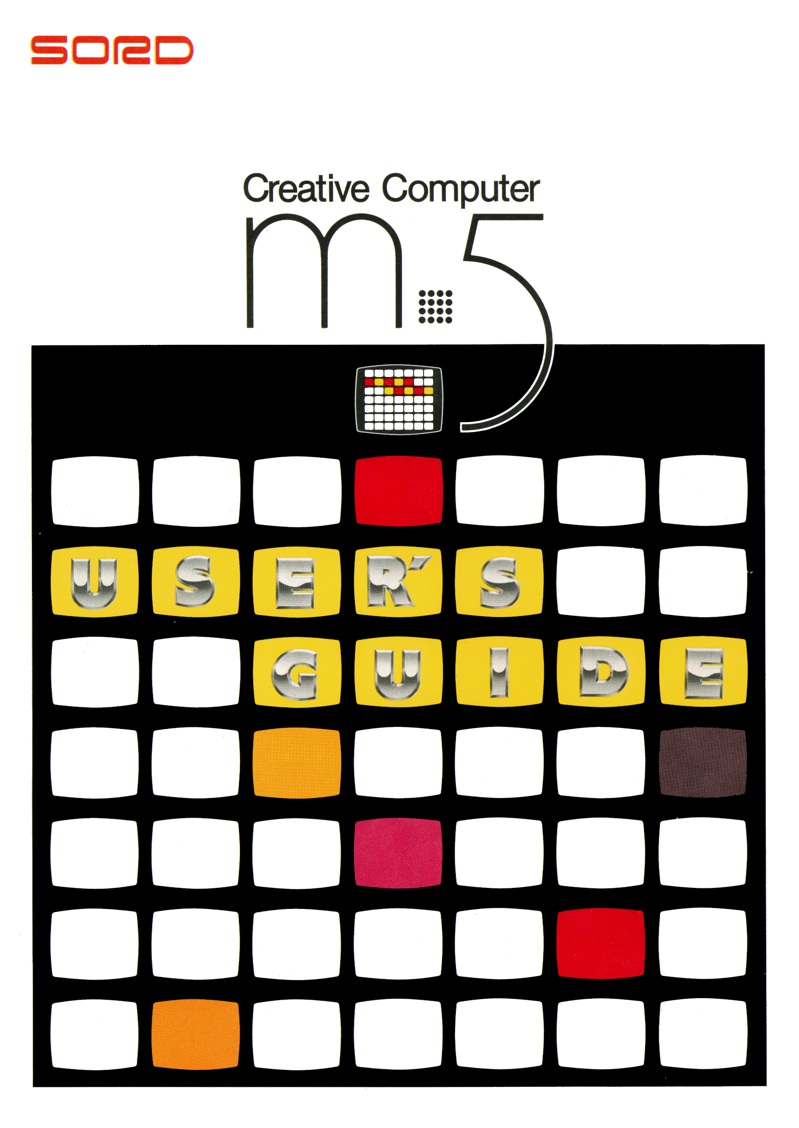

Ways You Can Use Your
M5 Creative Computer 2
M5 Creates a New World at Home 4
Looking After Your M5 5
How To Set Up Your M5 6
Running Your M5 8
Putting Your M5 Away 11
Cleaning Your M5 11
M5 Options 11
Playing Games With Your M5
- Baseball Game 12
- “Zac Banic” 14
What To Do If Your
M5 Doesn’t Work Properly 16
M5 Specifications 17
Copyright © 1983 by SORD COMPUTER CORPORATION
All rights reserved. Printed in Japan.
No part of this publication may be reproduced, stored in a retrieval system, or transmitted, in any form or by any means, electronic, mechanical, photocopying, recording, or otherwise, without the prior written permission of SORD COMPUTER CORPORATION

Ways You Can Use Your M5 Creative Computer

Be Creative with Up to 16 Colors!
The M5 Creative Computer lets you draw your own pictures in 16 different colors on your TV screen. Finished pictures can be stored on ordinary cassette tapes, and can be called back later. You can even combine two or more completed pictures to make entire scenes. [Uses the BASIC-G cartridge—sold separately]

Learn to Program BASIC!
What an easy way to join the computer age! We’ve created a special version of the BASIC computer language especially for beginners. Even if you’ve never used a computer before, you’ll be able to learn how to write your own programs by following the simple instructions. [Uses the BASIC-I cartridge — supplied]

Do All Kinds of Calculation from Baseball Statistics to Calorie Counting!
Everyone in the family will enjoy using the M5 for all kinds of calculations. There’s no programming necessary. You can record household expenses and have the M5 calculate the amount spent on different budget items. Or use it to log automobile trips made and calculate gas mileage. [Uses the FALC cartridge — sold separately]

Great for Science or the Stock Market!
The M5 can be immensely practical in addition to being fun. Floating-point calculations and scientific functions make the Creative Computer perfect for mathematics, science and all sorts of other applications. [Uses the BASIC-F cartridge — sold separately]

Play Baseball and Other Games!
You’ll have hours of fun playing games with your M5. Just plug in the game cartridge of your choice. [Uses game cartridges — sold separately]

Other Programs
Software under development includes the following:
- A sprite Creation Program
- A page Display Creation Program
- Programs to make the animation function fuller and easier to use
- Programs for communication with other computers
- New computer languages for education
- Programs for education

There are also plans to offer the following:
- A symbolic debugger
- The source program list for BASIC-I
- Hardware circuit diagrams
These will enable the M5 to be programmed in machine language, for people who want a fuller understanding of how computers work.

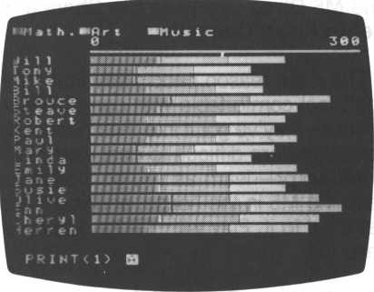

M5 Creates a New World at Home

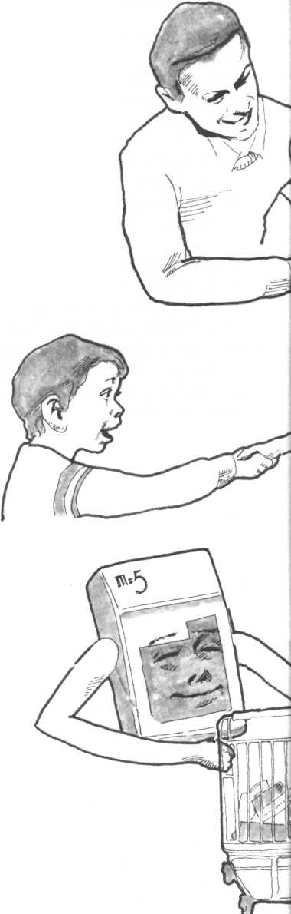
The M5 Gives Everyone the Chance to Get to Know Computers
The main reason people say that they don’t feel comfortable with computers is because they’ve got it into their heads that computers are difficult to deal with.
Don’t worry—learn as you go along! Just keep the M5 in the house, and you’ll soon get used to it. Play with the keys and have fun!

The M5 Helps Teach Children
Use the M5 to helps children of all ages learn. Begin with games, drawings and learning numbers and letters, then go on to calculations for math and science. The M5 is a good introduction to computers for children growing up in the computer age. It helps them to think flexibly and gives them lots of opportunity to be creative.

The M5 Helps Parents, Too
Leave all your home office work to the M5: household finances, loan calculations, purchase planning, menus and dietary planning, address management, you name it, the M5 can handle it. Even if you don’t know BASIC, “FALC” will let you do all you want to. And for fathers having a hard time coming to terms with computers at work, the M5 can prove a great aid to understanding computers and their applications.

Looking After Your M5

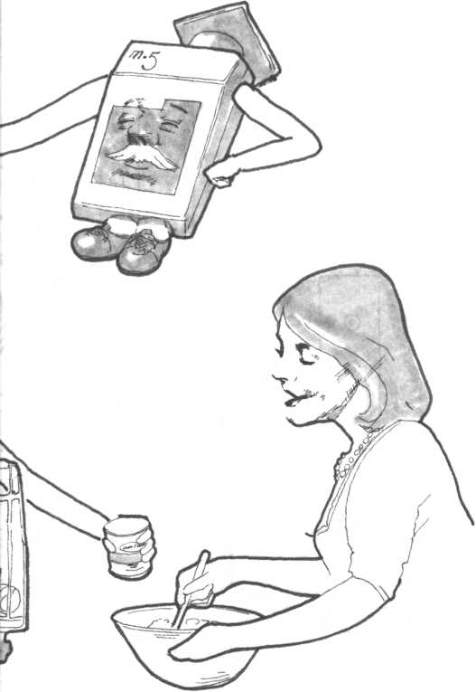

Here are a few recommendations to
keep your M5 in top condition.
- Don’t throw or drop the M5.
- Don’t spill any liquid over the M5.
- Don’t try to open up the M5.
- Don’t put anything on top of the M5.
- Don’t use sprays or chemically-treated cloths to clean the M5.
- Don’t leave the M5 in a hot place or in direct sunlight.
- Don’t pull the M5’s cables.
- Don’t store the M5 in a dusty or humid place.

Here are a few recommendations about looking after your program cartridges and cassette tapes.

Program cartridges
- Don’t open up program cartridges or try to put anything inside them.
- Don’t touch the program cartridges’ metal terminals.

Program cassette tapes
- Don’t leave cassettes near speakers, because speakers contain magnets which can erase or alter program contents.
- To avoid the tape getting tangled, make sure it is wound tightly before using it.

How To Set Up Your M5

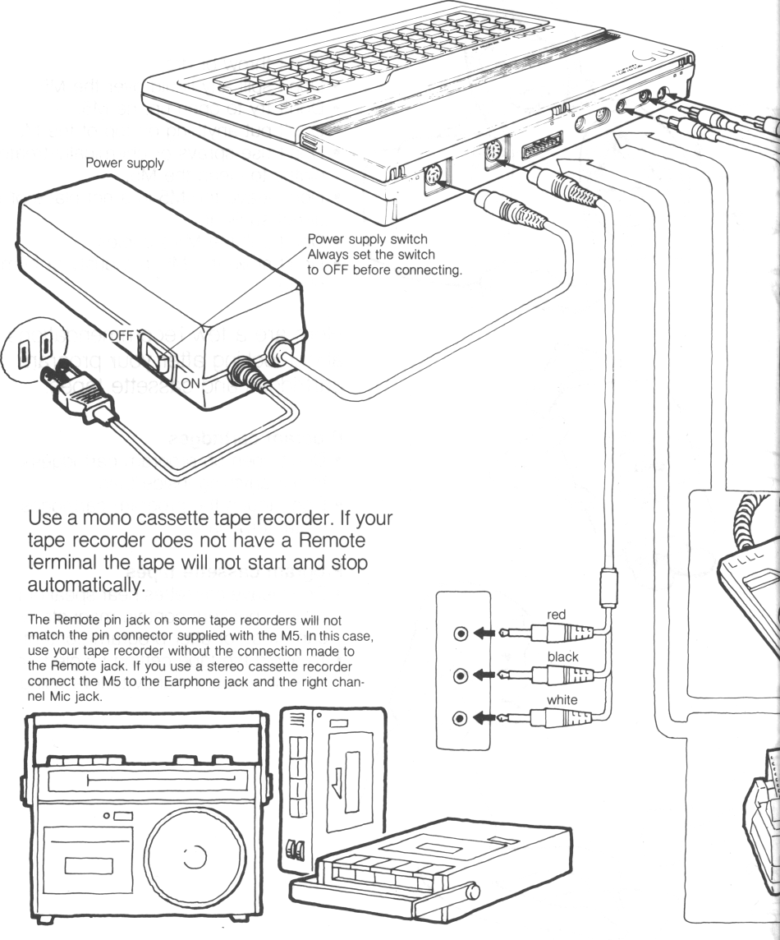
To run your M5, first connect the power
supply, cassette tape recorder and
TV set as shown in
the diagrams.
Wall outlet

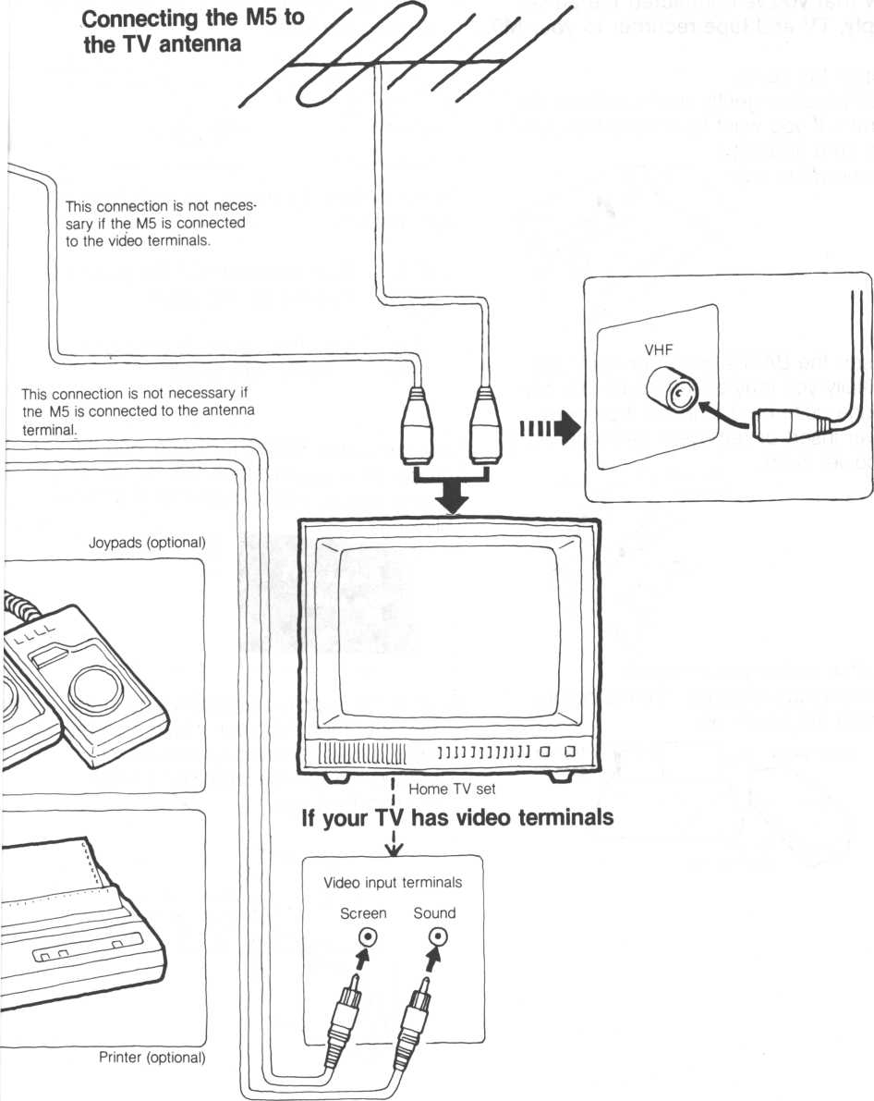

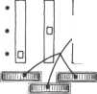
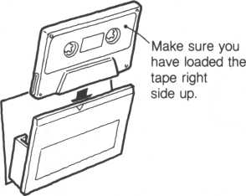

Running Your M5
Tuning switch: to adjust, press switch in and turn.
Tuning switches k (preset)
1. Open the cover
Lift the cover gently as shown in the diagram. If you want to remove the cover, be sure and put it
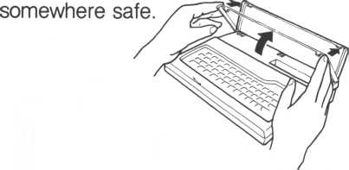
For a rotary switch For electronic tuning
*If the picture still moves up and down or right and left:
Use this control if the picture is moving right to left.
2. Insert the BASIC-I program cartridge. Initially you may have to push the cartridge quite hard to insert it properly.
* Never insert or remove a cartridge while
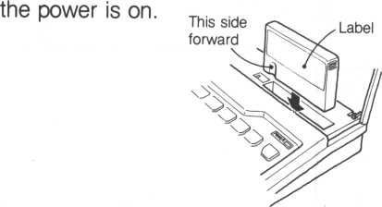
3. Switch on the power supply
*The cartridge must be inserted before you turn the power on.
blinking?
5. Load the supplied program tape in the cassette tape recorder. Make sure the tape is fully rewound. (If you disconnected the remote lead, don’t forget to connect it again.)

Now that you’ve connected the power supply, TV and tape recorder to your M5...
4. If the TV picture is wavy or fuzzy, adjust it using the tuner.

Use this control if the picture is moving up and down.
Vertical
hold

Horizontal
hold

Are the words BASIC-I, READY and the character A displayed on the screen as shown below, and is character A (cursor)

On some TV’s the letters may be cut off on the left.

Basic-I
Ready
A

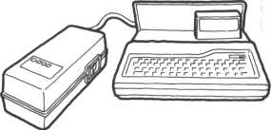
Power supply
The red light goes on.

Set the switch to ON

There are three game programs supplied on tape: a TV test pattern program for adjusting your color TV to the M5, a “ZAC BANIC” game program, and a “BASEBALL” game program.

If you don’t hear a click and the tape keeps playing,
this means that the M5 hasn’t read the program. In
this case, do the following:
- Stop the tape.
- Switch the power off, then back on again.
- Rewind the tape. (If the recorder has a remote terminal, disconnect the jack from It to enable you to rewind.)
- Reconnect the jack to the remote terminal.
- Turn the recorder’s playback volume up.
- Repeat steps 6 and 7.
• We recommend you establish a suitable volume level, then mark it.

- Having loaded the tape in the tape recorder, press the PLAY button. If the tape recorder doesn’t have a remote terminal, perform step 7 before this step.

- Press keys TAPE and RETURN in that order.
You should hear a click, the tape starts playing automatically, and the M5 reads the first program. The program name is displayed on the screen.
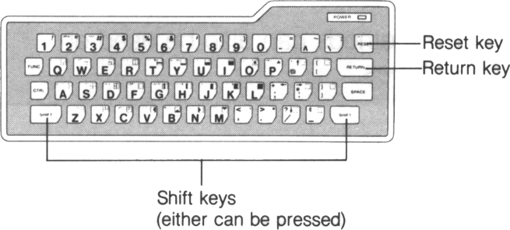
When the M5 finishes reading the program, you should hear another click, then the tape stops automatically.
*If your tape recorder does not have a remote terminal, the tape will not start or stop automatically. In this case, perform step 7 before step 6. When the entire program has been read off the tape and the game display appears on the screen, press the Stop button on the tape recorder.
*The recorder volume control should be set at 8 or 9 to ensure reliable operation.
TV’s and other electrical appliances may be a source of noise which can interfere with proper recording onto cassette tape. Keep your tape recorder away from such possible sources of interference.

- To read the next program after the M5 has finished reading the first program:
Press the SHIFT and RETURN keys at the same time. The tape starts playing automatically from when it stopped, and the M5 starts reading the next program.
When the M5 has read the next program, the tape stops automatically and the baseball game is displayed.
*If using a tape recorder without a remote terminal, first rewind the tape a little, then perform step 7 and press the play button.

When you finish playing the baseball game and you want to go on to play “Zac Banic”, perform step 8 again.
When you want the M5 to read a program without reading the preceding programs:
These methods can also be used on other tapes.
Method 1:
- Start from step 6.
- When the name of a program you don’t want is displayed, press the RESET key. This tells the M5 to ignore that program, the tape keeps playing, and the M5 reads the next program automatically.
Method 2:
Using the tape counter as your guide, fast forward the tape to slightly before the program you want the M5 to read. Then start from step 6 to enable the M5 to read the program.
* Between each program on the tape is an empty space. A beep indicates the beginning of a program. To correlate programs with the tape counter, disconnect the jacks, play the tape, then note down the numbers on the counter when the beeps sound.

When Entering Data
Press the 2 key while holding the FUNC key down to change to graphics character input from the keyboard.
When graphics characters are entered, the cursor is represented by character G. Pressing the 1 and FUNC keys changes the cursor back to character A to enable you to enter alphabetic characters. If you notice a mistake before pressing the RETURN key, press the DEL and CTRL keys simultaneously. Pressing the DEL key backspaces the cursor to the previous character position. The erroneous character is deleted and you can reenter data. The cursor backspaces once each time you press the DEL key.
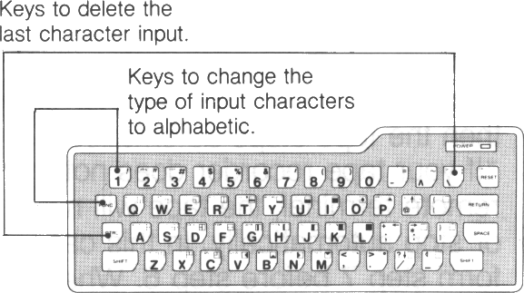
If you notice your mistake after pressing the RETURN key: the cursor reappears on the screen. Enter the correct data.

Adjusting Display Colors When the M5 Is Connected to Your TV
First, load the TV adjustment program tape as described on pp 8 & 9. The picture appears and you should hear a beep. Adjust the picture using the switches on the
front or side of your set so that the display is clear. Also, set the volume appropriately.
The aim is to adjust the picture so that you will be able to watch is without straining your eyes.
*Tuning switches are usually set to standard positions.

Putting Your M5 Away
- Turn the TV off.
- Turn the M5 power off. -
- Remove the cartridge.
- Unplug the cables.
*When unplugging cables, hold the actual plugs as shown in the diagram, don’t try to pull them out by the cable.
- Put the cover back on.
*If you took the cover off, don’t forget to put it back on.
- Store all parts carefully.
*Don’t forget to put the power supply away too.

Cleaning Your M5
When it is very dirty:
Soak a soft cloth in diluted detergent, wring out thoroughly, then wipe off dirt. Wipe again with a dry cloth. When there is some dust in the cartridge connector: Blow the dust out with a blow-brush as shown in the diagram. Never clean metal connectors with detergent as this may cause malfunction.

M5 Options

Options
Joypads
Used for playing games on the M5.
Each one has eight direction controls and an attack button.
Educational programs
There are plans to offer educational programs for the M5 on cartridges or cassette tapes, at the following levels: Kindergarten; lower elementary school; higher elementary school; junior high.
Printer
Used for printing BASIC programs created using the M5, execution results, and FALC data.
(There are plans to introduce a special printer for the M5 soon.)
Game programs
There are also plans to introduce a whole range of games intended for the M5 stored on cartridge or cassette tape.

if you do not know how to adjust them, just leave them where they are.
Volume control.
M5 game programs produce sound effects. Adjust the
volume to an appropriate level. When you’ve finished adjusting your TV, press the SHIFT and RESET keys simultaneously. The M5 is ready to read the next program, the baseball game. (For details, see page 12, step 8.)

Playing Games
With Your M5 1. Baseball Game
*Joypads cannot be used with this game.
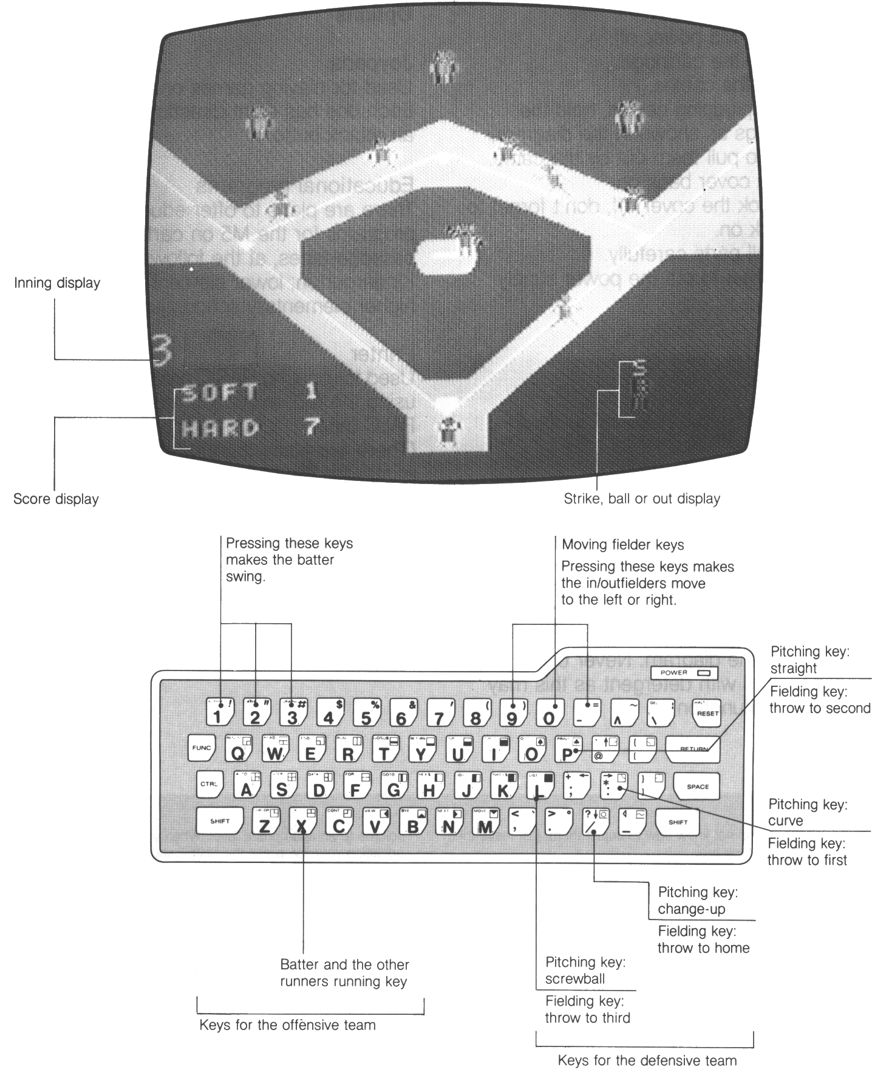

Pitching
P Straight pressing this key
produces strikes every time.
: Curve pressing this key
produces strikes half the time.
L Screwball pressing this key
produces strikes half the time.
/ Change-up pressing this key pitches
a slow ball. Pressing the key after a pitch has been thrown slows the ball down from the instant the key is pressed.

Fielding (After the ball has been
caught)
9 pressing this key moves both in
fielders and outfielders to the left.
0 pressing this key stops fielders
moving.
— pressing this key moves both in
fielders and outfielders to the right.
: pressing this key throws the caught
ball to first.
P pressing this key throws the caught
ball to second.
L pressing this key throws the caught
ball to third.
/ pressing this key throws the caught
ball to home.

Batting
The batter can be made to swing at the ball using either the 1, 2 or 3 keys; the effect will be the same with any key used.
If the batter swings in time, he hits the ball. There are three types of hit balls; flies, grounders, and fouls. A ball which goes past the fielders counts as a hit, and both batter and runners advance automatically. There are four types of hits: single, double, triple, and home run.

Running
X Pressing this button starts the batter
running toward first base after he hits the ball, and advances all base runners at the same time.

Game Start
When the tape has been completely read in, the game starts automatically.
After 9 innings, the game starts over.

When you finish playing this game:
- If you want to play a different game, press the RESET and SHIFT keys at the same time. (For details, see page 11, step 8.)
- If you are not going to use the M5 for a while, or are going to change cartridges, switch the power off.
This baseball game is stored on the supplied cassette tape. To find out how to start the game, see page 8, “Running your M5”.

Playing Games
With Your M5 2. “Zac Banic”
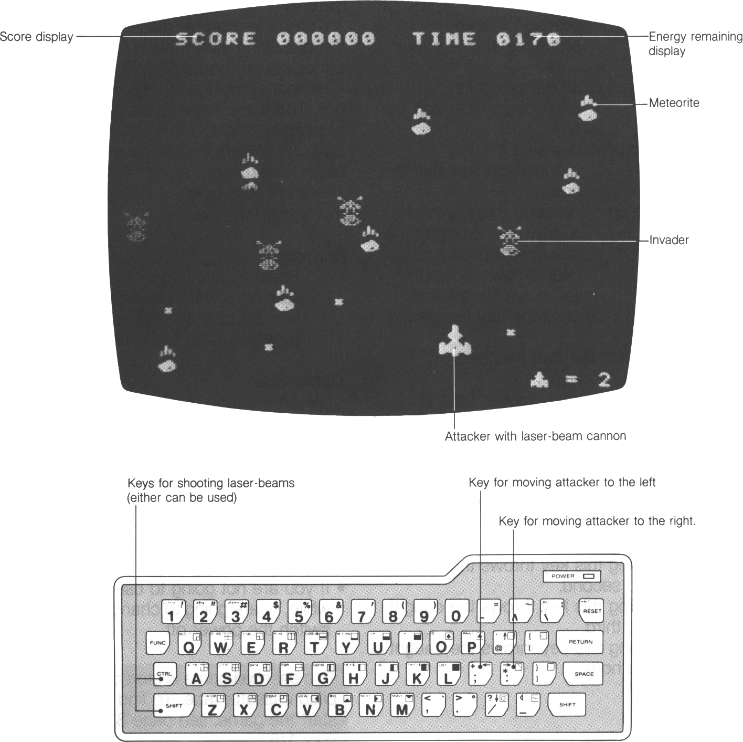

In this game, you have to attack invaders
hiding behind meteorites,
while avoiding meteorites flying at you.

How to Play “Zac Banic”
Shooting down an invader scores 100 and adds energy to the attacker’s supply.
Zapping a meteorite which has no invader behind does not score.
The game ends if the attacker crashes into a meteorite, is attacked by an invader, or runs out of energy. Energy remaining is displayed at the top left of the screen.

Game Start
The game starts automatically after the entire program has been read off the cassette tape.

Game Over
The game ends when “GAME OVER” is displayed on the screen. If you want to play the game again, press the 1 key.

When you finish playing this game:
- If you want to play a different game, press the RESET and SHIFT keys at the same time. (For details, see page 11, step 8.)
- If you are not going to use the M5 for a while, or are going to change cartridges, switch the power off.

Suggestions
Don’t sit too near the screen. About one meter away is the best distance.
Don’t play the game for too long at a time. Have a rest from time to time to avoid straining your eyes.

This "Zac Banic" game is stored on the supplied cassette tape. To find out how to start the game, see page 8, "Running Your M5".

What To Do If Your M5 Doesn't Work Properly
Condition | Cause | Solution
No picture | The power supply is off. The program cartridge is not set.  Cables connected incorrectly.  Wrong TV channel. | Switch the power supply on. Set the program cartridge.  Connect cables correctly.  Select correct channel.
No sound | Cables connected incorrectly. | Connect cables correctly.
Program not read from the tape. | Cables connected incorrectly.  Recorder volume too low. Steps taken in wrong order. | Connect cables correctly. Turn recorder volume up. Read manual again, then take steps in the right order.
Cassette tape does not run. | Cables connected incorrectly.  Steps taken in wrong order. | Connect cables correctly. Read manual again, then take steps in the right order.
Screen displays meaningless characters or graphics, and data cannot be entered. | M5 is not working properly. | Turn power off, then back on again.
If the solutions suggested on this page do not solve the problems, switch the power off, then take your M5 back to the store where you bought it, together with the guarantee.

